Biological Grounds of Resilience of the Arctic Copepod Calanus glacialis
in the Sub-Arctic White Sea (66° N) to the Life at the Range Margin

Daria M. Martynova*¹, Nikolay V. Usov¹, Vadim M. Khaitov^{2,3}, Inna P. Kutcheva¹, Svetlana A. Murzina⁴

¹ Zoological Institute, Russian Academy of Sciences, St.Petersburg, 199034, Russia
2
3
⁴ Institute of Biology, Karelian Research Center, Russian Academy of Sciences, Petrozavodsk, 185910, Russia

*corresponding author daria.martynova@gmail.com

Abstract
In the White Sea Calanus glacialis annual vertical distribution, feeding and reproduction peculiarities, as well as lipid dynamics through the year are governed by both temperature and feeding conditions. The life cycle of this species tends to prolong up to four years, with two obligatory years. The females are highly dependent on the food sufficiency during the reproduction period. C. glacialis in the White Sea may employ omnivorous feeding comparing to this species, described as predominantly herbivores in the high Arctic. The most vulnerable developmental stages are CIII and CIV copepodites, which face with food limitation in the first summer due to mismatch between the delayed molt and hydrological regime of the White Sea. The CIV copepodites then feed in the end of the summer, when temperature of productive upper water layers decreases, and thus complete lipid storing successfully. The scenario of global warming impact on the species biology is discussed, basing on high species flexibility and adaptation to adverse environmental factors in the White Sea.

Keywords: Calanus glacialis; the White Sea; life cycle strategies; feeding; reproduction; lipids; temperature optima

INTRODUCTION
Calanus glacialis gets a tremendous amount of attention as one of the key copepod species in the Arctic seas (Eilertsen et al. 1989; Daly 1997; Thibault et al. 1999; Juul-Pedersen et al. 2006; Wassmann 2006; Olli et al. 2007), especially with the increasing interest in the last decade to the climate change (Walsh and Timlin 2002; Hansen et al. 2003; Falk-Petersen et al. 2007; IPCC 2007; Kaartvedt 2008). Numerous publications are devoted to annual vertical and spatial distribution of this species, its feeding and reproduction ecology, lipid status and many other peculiarities of the species biology. Only several reviews may be named here since citing all the literature on C. glacialis biology include more than a hundred publications (Huntley 1988; Tande and Henderson 1988; Conover and Huntley 1991; Hirche and Kattner 1993; Albers et al. 1996; Heath et al. 1997; Niehoff 1998; Tamelander et al. 1998; Madsen et al. 2001; Beaugrand et al. 2002; Niehoff 2007; Riser et al. 2007; Falk-Petersen et al. 2009).
In the Arctic seas, C. glacialis is described as a species with various life spans, which may finish its life cycle in one calendar year overwintering south of the polar front (Conover 1988), in the Greenland Sea (Smith 1990), the Davis Strait (Huntley et al. 1983) and the Sea of Okhotsk (Safronov 1984) or may be prolonged up to 3 years in the northern areas and in the White Sea (Conover 1988; Kosobokova 1998, 1999). Generally, the scheme of the life cycle is similar for all the areas and includes spring reproduction, summer growth and moulting to elder copepodite stages with simultaneous lipid storage and overwintering as a diapausing copepodite with food-independent molt to mature stage (Conover and Huntley 1991). The overwintering may occur once or up to three times depending on length of the productive period, which is closely connected with the region latitude, e.g. sunlight and ice regime (Falk-Petersen et al. 2009). The populations inhabiting lower areas have more chances to finish their life cycle in one year, and the length of the life cycle increases accordingly to getting North (Conover 1988; Falk-Petersen et al. 2009).
Calanus glacialis is one of the key copepod species in the White Sea, substituting up to 70% of total zooplankton biomass, especially in the deep areas (Berger et al. 2001). It was introduced by income of the Barents Sea waters after last glacial period and forms here an isolated population from the other Arctic seas for the last 5,000 yrs (Pertzova and Pantyulin 2005). As it is described before, the life cycle of this species in the White Sea may last for two or three years with overwintering as diapausing CIV (first winter) and CV (second winter) copepodites (Prygunkova 1968, 1974), sometimes as CF adult females (Kosobokova 1998, 1999). Gonad maturation, sexual differentiation and moulting to adults take place during the second year of development. The following autumn/winter is the major period of CV maturation, which occurs independently on food supply. The onset of female maturation occurs in February and March, ca. 2 months prior to the spring phytoplankton bloom. Reproduction takes place between April and June. It terminates in the second half of June and coincides with the warming of the surface water layer where egg laying is observed. Females of C. glacialis may survive for several months after reproduction and are able to winter again (Kosobokova 1998, 1999).
Calanus is assumed to have different feeding activity through the year, as the other species with winter diapause. However, the feeding patterns of C. glacialis in the White Sea were studied quite occasionally and fragmentary. Several outdated publications may be named, mostly for CIV-CV copepodites in the summer period (Perueva 1977a, 1977b, 1984), fed sometimes on algal monocultures (Arashkevich and Drits 1984; Sergeeva and Arashkevich 1991), all in Russian. Nearly nothing is known about the annual feeding activity of different developmental stages on natural seston. The female genital development and some reproductive peculiarities of this species in the White Sea was described by Kosobokova (1993, 1998, 1999), however, without any experimental assessment of food impact to gonad maturation and reproduction success of this species. Data on lipid biology of C. glacialis in the White Sea is quite scarce, describing only total lipid content (Arashkevich and Kosobokova 1988; Kosobokova 1990). The data on the temperature preferences of this species and spring vertical distribution correspond only to several years of observation (Kosobokova 1998, 1999). The scarcity of complex data on C. glacialis annual vertical distribution, temperature optima, feeding patterns, lipid and reproduction biology in the White Sea does not allow accurate comparing this local population with the rest, inhabiting the Arctic waters.
The present study was aimed to describe several important ecological features of Calanus glacialis, inhabiting the White Sea, e.g. (1) annual distributional and feeding patterns, (2) lipid biology and (3) early genital development and its relation with food sufficiency; as well as to assess the peculiarities of its life cycle strategy in the sub-Arctic sea.

MATERIALS AND METHOD
Hydrological studies, seston and zooplankton sampling
The seasonal dynamics of temperature, salinity, and vertical distribution of different developmental stages of Calanus glacialis in regard to environmental conditions has been studied in the Kandalaksha Bay, the White Sea (Table 1). The sampling and zooplankton counting were performed by standard methods (Zhadin 1960; Tsyban at al. 1981; Harris et al. 2000). At all the stations zooplankton was sampled by Juday nets with 0.1-m² opening diameter and different mesh sizes. Information on sampling scheme is presented in the Table 1. The samples were immediately preserved with formaldehyde (final concentration 2–4%). The counting was performed in the Bogorov’s counting chamber. The samples were concentrated to 100-mL or 200-mL volume according to the organisms' concentration assessed visually, and three 1-mL aliquots were taken from concentrated sample using a Hensen stempel pipette to count the stages whose numbers in an aliquot exceeded 10 ind.; rarer stages were counted individually in the whole sample. The abundance was expressed as a number of individuals per one cubic meter (ind. m⁻³)

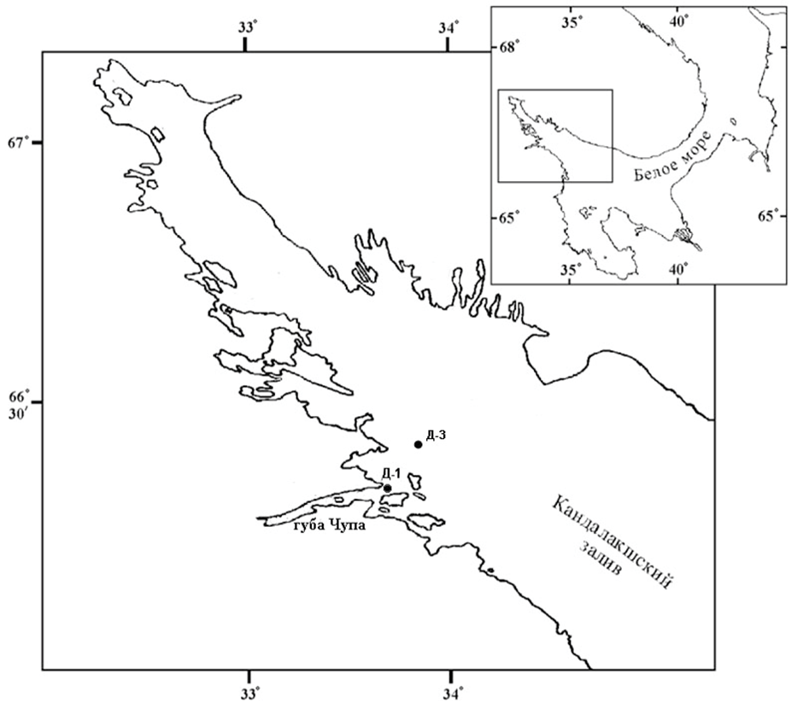
Fig. 1. Study region. – (добавить Д-2 и перевести названия)

Table 1. Sites of zooplankton sampling and their characteristics.
Station no. | Depth, m | Coordinates | Study period | Sampling periodicity | Mesh | Zooplankton sampling
D-1 | 65 | 66^{о}19.8ʹ N, 33^{о}39.7ʹ E | 1961-2019 | Year round, every 10 days during ice free period and monthly from the ice. | 200 μm | 0-10 m,  10-25 m,  25-65 m
D-1 | --"-- | --"-- | 1998-2019 | The same. | 100 μm | The same
D-2 | 112 | 66^{о}19.8ʹ N, 33^{о}39.7ʹ E | September, 27-28, 1997  July, 1-2, 1998 | Eight times in 24-h period, with reference to the tidal dynamics: twice at low tide and twice at high tide and four times at half tide. | ??? | 0-10 m,  10-25 m,  25-50 m,  50-110 m
D-3 | ca. 180 | 66°26.145' N, 33°55.123' E | 2012–2019 | Once a month from May to November or rarer. | 200 μm  +  100 μm | 0-10 m,  10-25 m,  25-50 m,  50-100 m  100-200 m

The diel vertical migration patterns of different developmental stages of C. glacialis were studied for early summer and autumn periods at station D-2 (Table 1). The diel dynamics of the vertical distribution was analyzed. The migrations have been registered if the difference in copepod abundance exceeded 30% between the neighbouring water layers when comparing two subsequent samplings.
Temperature is measured in parallel to the zooplankton sampling. During the period of 1961–2006, the water temperature was measured by reversing thermometers mounted on the Nansen bottle (BM-48) at 0-, 5-, 10-, 15-, 25-, 50-m depths and near the bottom (63–65 m) or by bathythermograph GM7-III. Since 2006, the water temperature is measured by CTD probe MIDAS CTD+ (Valeport Ltd.) on continuous profiles from surface to bottom. Prior to active application of the new equipment, CTD was intercalibrated with reversing thermometers and bathythermograph. No significant discrepancies were found within the limits of accuracy of the previously used equipment.
D-3 описание координаты
The seston sampling was performed during 2000-2008 at station D-1, major characteristics (dry weight, Chl a, C_{org}, N_{org}) were analyzed at the standard depths (see above) simultaneously with zooplankton sampling. Filters with seston were immediately placed to 90% aqua acetone (Evans et al. 1987) after filtering for further analysis of Chl a and phaeophytine (here and further phytopigments); standard analytical methods have been applied (Bathmann and Liebezeit 1986). Prior to CN analysis, filters were gently washed with 3-6 drops of 1N HCl to remove all inorganic C, rinsed with 10 mL distilled water under 0.4 Pa vacuum and dried for 24 h at +54 °C to constant weight. Organic C and N content was measured at Carlo Erba NA 1500 Analyzer using standard techniques in the Department of Biological Oceanography, Alfred-Wegener Institute (Bremerhaven, Germany). Pigment per carbon ratio (PPC, µg µg⁻¹) was calculated according to Harris et al. (2000).
Commonly accepted abbreviations of copepodite developmental stages are used in the text: CI—CV are the immature copepodite stages I—V, CF are females. Males were presented singly and were not considered for any analysis.

Seasonal dynamics and vertical distribution of C. glacialis abundance
The temperatures of spring Calanus disappearance (different developmental stages) from layers 0–10 m and 10–25 m were defined when the long-term average abundance decreased to zero. The temperatures of minimal abundance were found for CIV copepodites, which were presented all the year round in the water column. The temperature range of maximal abundance was recalculated as well for the period of the stage presence. Optimum temperature range for each developmental stage was calculated according to original method with some modifications (Zubaha and Usov 2004). The highest values of optimal temperatures of nauplii and stages CI, CII, CV and females were calculated for upper 25-m layer for cases, when more than 75% of total stage abundance (weighted average) was concentrated here. Stages CIII and CIV were considered in total water column, since these stages were distributed evenly through the whole water column.

Feeding peculiarities
Feeding was studied in the series of the experiments in different seasons of 2005--2008. Zooplankton was sampled at station D-2, 110 m depth, by means of closing Juday net (100 μm mesh, 0.1 m² opening mouth) by vertical tows from standard water layers of 110-50 m, 50-25 m, 25-10 m and 10-0 m. The samples were diluted by fresh seawater taken by 5-L Niskin bottle from depth of 0ºC water temperature, placed in 2-L Pyrex glass bottles in the Coleman box and immediately transported to the shore laboratory. The copepodites of prevailed developmental stage were sorted under the dissecting microscope and acclimated to the experimental conditions for at least 48 hours. From 10 to 20 specimens were placed in 1-L Pyrex glass bottles (4--6 replicates) filled in with the water from the fluorescence maximum, previously filtered through 200-μm mesh. The amount of the specimens used in one replicate depended on the copepod size, e.g. the number of large specimens placed in one bottle was less than for the small ones. The copepods were incubated for approximately 24 h on the plankton wheel with 2.0 rpm in cooled dark container at 1.0±0.5ºC. Three bottles without copepods were used as controls. At the end of the incubation, the entire bottle contents were filtered through a 200-μm mesh submerged sieve, the copepods were checked for activity, and faecal pellets were counted under a dissecting microscope. After the experiment ended, 100 mL of water was fixed with buffered formaldehyde (2% final concentration) for further phytoplankton counting, and two portions of 450 mL each were filtered under 0.3 Pa vacuum on precombusted Whatman GF/F glass fiber filters for further analysis of phytopigments and CN content of POM (0.2-200 μm size fraction). After the experiments, the specimens were blotted dry, placed individually in polypropylene 1.5 mL Eppendorf cups, and then frozen and stored in a –80ºC freezer for later biochemical analysis. The same procedure was applied to GF/F filters.
Ingestion rates of POM in terms of organic C and Chl a were calculated assuming exponential growth and constant ingestion rates (Frost 1972; Tackx and van der Vrie 1985; Meyer-Harms 1996). Percentage of ingested phytoplankton as a part of total consumed organic C was calculated using PPC ratio (Harris et al. 2000).
The selectivity of phytoplankton species has been assessed using Utermöhl counting. The food particles in control bottles without copepods and bottles with copepods were counted for 100-mL sub-sample under standard techniques (Utermöhl 1958) at the beginning and at the end of experiment using DAPI as fluorescence marker. Particles in the samples of natural seawater were counted totally due to low concentration of phytoplankton in winter. Each phytoplankton species was subdivided into three groups: (1) intact “full" cells with chloroplasts; (2) intact "empty” cells without chloroplasts; (3) broken cells. Chain-forming phytoplankton species were treated as solitary cells and cell chains. Chaetoceros, Pseudonitzschia and Thalassionema species were counted under three size groups: (1) cells <50 μm; (2) cells of 50-100 μm and (3) cells bigger than 100 μm (if applicable). Due to the fixation procedure, only thecate dinoflagellates were conserved nicely to distinguish the genera. Most of athecate dinoflagellate species need special fixation and processing by highly experienced personnel, thus we did not analyze this group here.
Primary data sorting was applied before the calculations of selectivity were performed. Only when certain phytoplankton species concentration in the beginning of experiment was not less than 50 intact “full” cells per liter, this species was further used in analysis. To determine whether significant changes in food particle density occurred between different treatments, Kolmogoroff–Smirnoff Two-sample-tests (Zar 1996) were employed for food item at a = 0.05. Differences in food particle density between t0-replicates and controls were tested to verify for mortality or growth of each phytoplankton species. The same was applied for initial concentration of intact cells and final concentration of broken ones of the same species in bottles with consumers. Differences in food particle density, after incubation, between controls and samples with consumers were tested to verify potential ingestion for each phytoplankton species. Only when significant differences between samples with and without added consumers were found at a = 0.05, it was assumed that ingestion of this species or particle group occurred. To test whether the composition of the particle mixture offered significantly differed from the composition of the food ingested, Chi2-tests (Zar 1996) were performed for each experiment at a = 0.05. Only when p < 0.05, it was assumed that selective feeding occurred during a specific experiment (Schwamborn et al. 2004). For experiments, where Chi2-tests confirmed the occurrence of selective feeding, the Chesson electivity index ("epsilon" e) was calculated for each food item (Chesson 1983). The values of e may range from -1 to 1, where a value of zero means no selection. The index "epsilon" was obtained for each food item by calculating first Manly’s preference index, which considers food depletion during experiments (Manly et al. 1972). Manly’s preference index was then transformed to the scale of "epsilon" using Chesson’s equation (Chesson 1983), rather than using a linear transformation to the scale of "epsilon" (Schwamborn et al. 2006).

Observations on early genital development and cephalosome morphology
Cephalosome length and width of CIV and CV copepodites, and females were measured under the microscope with 0.05-mm accuracy in order to find the differences between the cohorts (generations) and thus to search for possible prolongation of the life cycle on this species at these particular stages, as evidenced for C. hyperboreus (Ji et al., 2012). In total, 1,483 individuals sampled at station D-1 from February through July, 2005—2008 have been measured. Cephalosome length (L_{c}), width (W) and L_{c}/W ratio for each stage and layer were compared with Student t-test.
Three series of the experiments on the gonad development were performed in March--April, 2008. The ice cover on April, 15, 2008, was about 40 cm; however, the ice algae colonies were quite disperse (less than 2-3 ones per 100 cm²). The number of colonies did not increase until the ice melting. First zooplankton samples were taken on March, 16, 2008, by vertical tows of Juday net (35 m—surface) with hand winch from the ice at station D-1. The samples were placed in 2.0 L plastic vials in Coleman box and immediately transported to the shore laboratory. Calanus females were gently picked up with plastic pipette and measured individually by prosome length and width. Gonad status was determined by adjusted table of Smith et al. (1990) and Kosobokova (1999) (Table 2). Additionally, colour characteristics were checked as “red” – bright coloured by chromatophores on antennas, genital pores and gut; “pale” – with minor chromatophores presence or even without any. First fifty females, selected randomly, were placed individually in 2-L Pyrex glass bottles filled with ambient seawater (pre-sieved via 200-μm mesh) from 0—25-m water layer. The bottles were gently turned upside down several times during the incubations to reduce settling of algae (Calbet et al. 2002), 500 mL were replaced every day, and the whole water volume – every fifth day. The pellets were picked up and counted every day. The rest of females, 202 specimens, were placed in the 30-L container with filtered (GF/F, 0.2 μm) seawater. One half of the water volume was replaced every fifth day. The observation of genital status both for starved and fed females were conducted every fifth day. At the same day, or day before, the zooplankton sample was taken from the ice to compare genital status of natural Calanus population with animals under laboratory conditions. Unfortunately, rapid and crucial weather change on March, 30-31, 2008, made further zooplankton work on the ice impossible due to fast ice melting. The seawater for the experiment then was taken from the shore ice edge. ANOVA/MANOVA analyses were applied in order to find the differences in gonad stage for fed and starved animals, as well as to search for effect of the colouration on the cephalosome dimensions and gonad stage.

Table 2. Calanus glacialis female reproductive stages, with original modifications of Smith et al. (1990) and Kosobokova (1999)
Stage | Morphological description
G1, young immature | Only compact ovary visible, the diverticula are thin bands and widely separated from each other.
G2, immature | Small oocytes in the ovary, the diverticula are thin bands and widely separated from each other.
G3, semi-mature | Small oocytes in the ovary, single rows of oocytes are extending forward from ovary to diverticula. Medial walls of diverticula tend to force together.
G4, pre-mature 1 | Small oocytes in the ovary, rows of oocytes larger than in ovary are extending forward from ovary to diverticula. Single oocytes may be found in the oviducts. Medial walls of diverticula are very close to each other. Ovary larger than for state G3.
G5, pre-mature 2 | Oocytes of different sizes extending forward in diverticula. Medial walls of diverticula force together. More than one row of the oocytes are visible in the oviducts in the lateral view. Large oocytes are visible in the medial row in diverticula.
G6, mature | Large oocytes are densely packed in the diverticula and occupy much of the cephalothorax. Abutting medial walls of diverticula extend forward from ovary as a dark line to anterior cephalothorax. Large oocytes are visible in the oviducts in lateral view extending posteriorly to fifth thoracic segment.
G7-G9, Semi-spent, spent, rematuring | Not observed

Biochemical analyses
The lipid and CN samples were taken in accordance with the sampling of the animals for the feeding experiments and periodically during the zooplankton tows. Animals were immediately transported in dark containers to the laboratory. Live copepods were sorted by species and developmental stages under the dissecting microscope in a Petri dish (20 mm diameter) on the ice. Three to eight samples (1-15 animals of certain developmental stage each) were prepared for dry weight (DW), organic C and N analysis. Copepods were placed onto pre-weighed and dried GF/C filters (25 mm diameter, dried in 180°C for 24 h), then the filters were gently washed with filtered seawater (1 µm) and with 3-5 mL of distilled water on the 0.1 Pa vacuum, placed onto the dried (180°C for 24 h) aluminium foil envelopes and dried at 56°C for 24 h. Filters were cooled with silica-gel down to the constant weight and then weighed with 0.01-mg accuracy. The rest of the animals in the live samples were immediately fixed for fatty acid analysis. Three replication, 15 to 50 freshly sampled copepods each, were prepared in regard to the developmental stage. Copepods were taken with a plastic pipette and then placed to the pre-weighed 2-mL polypropylene Eppendorf cups, pre-washed with dichloromethane:methanol (2:1, v:v), hereinafter, DCM. Copepods were gently washed with cold distilled water and then dried on the Kleenex tissue. In each cup, 1.5 mL of DCM has been added; five cups with the same volume of DCM for each tow were treated as blank samples. The animals were immediately frozen at –30 °C and stored in these conditions until analysis (Falk-Petersen et al. 1987; Tande and Henderson 1988). In females, the gonad state was noted (Table 2). Lipids were extracted according to Folch et al. (1957). The fatty acid and alcohol compositions were determined by gas chromatography (Kattner and Fricke 1986). Briefly, lipids were hydrolyzed in methanol containing 3% concentrated sulphuric acid, and fatty acids were converted to methyl esters by trans-etherification at 80 °C for 4 h. Fatty acid methyl esters and free alcohols were then analyzed at a gas liquid chromatograph (HP 6890N) on a 30 m x 0.25 mm i.d. wall-coated open tubular column (film thickness: 0.25 µm; liquid phase: DB-FFAP) using temperature programming. Fatty acids and alcohols were identified by standard methods, including GC-MS. The analysis of FA content and assuming the trophic markers was performed according to Graeve et al. (1994 a, b), Albers et al. (1996) and Stevens et al. (2004 a, b, c). The FA analysis was performed only for WE and TAG lipid fraction.

Statistics
Vadim

RESULTS
Seasonal dynamics of hydrological parameters and seston concentration in the White Sea
March is the coldest month with average temperature of -0.9±-0.3 °C in 0–10 m layer; August is the warmest one, the average temperature of 13.4±1.2 °C in the same layer, according to long-term data (Fig. 1). The most pronounced temperature stratification of the water column takes place in July and August, when temperature difference between layers 0–10 m and 10–25 m is 5.4 °C and 4.0 °C, correspondingly, and between 10–25 m and 25–65 m layers is 5.5 °C in July and 6.1 °C in August. Vertical homothermy is pronounced in April and November. The reverse stratification with a maximum of 2.0-°C difference is observed during winter, when deep layers are significantly warmer than surface waters. The salinity varies in a small value range, the most expressed changes are observed in 0–10 m layer, when salinity changes from 21.8±1.5 psu in April (ice melting period) to 26.4±1.9 psu in November. In 25-65 m layer, the salinity changes are the least pronounced, from 27.4±1.4 psu in August to 28.3±1.3 psu in April.
In later analysis, the vertical distribution of Calanus developmental stages was considered for the two layers, 0-25 m and 25 m-bottom.

Старая картинка

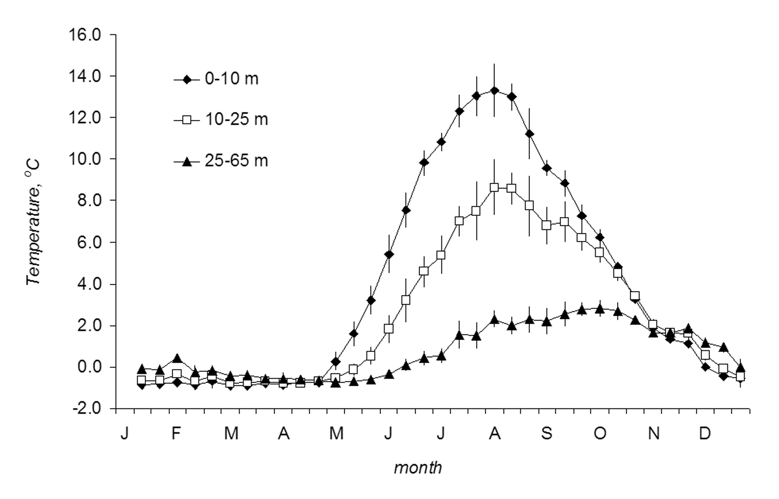
Fig. 1 Annual temperature curves for 1964-2018 period, station D-1. Dots – decadal mean temperature for the indicated water layer, vertical lines – standard error

Новая картинка

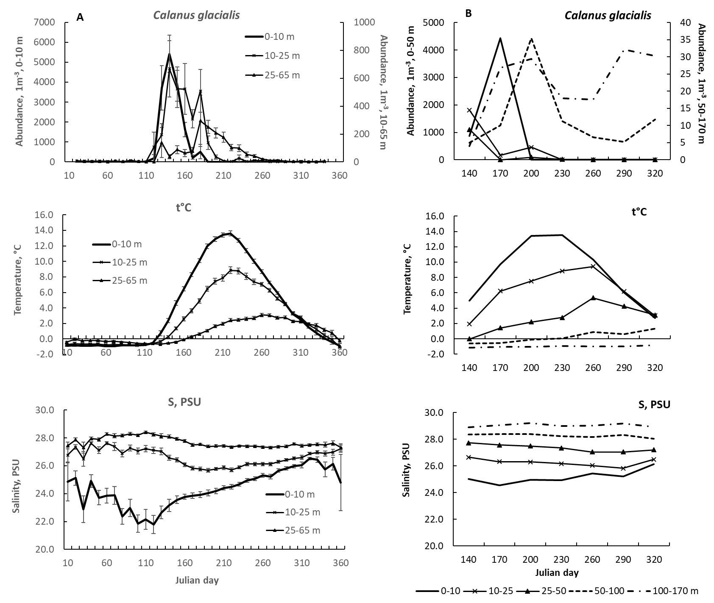
Рис. 1. Сезонная динамика численности Calanus, температуры и солености на станции Д-1 (A) и Д-3 (B) в разных слоях водной толщи. Для Д-1 приведены стандартные ошибки средних(для Д-3 они слишком большие из-за малой длины ряда).

The seasonal dynamics of seston organic C (particulate organic carbon, POC) was well-expressed in the productive upper 0-25-m water layer, the same for Chl a concentration (Fig. 2a). Two maxima were observed for Chl a concentration, in the end of May and through July. These maxima correlated with increased abundance of diatoms (Fig. 2b). Significant decline in diatom abundance occurred in the beginning of September. The POC dynamics was roughly comparable with Chl a dynamics, however, not necessarily, with one prolonged maximum through July and August (Fig. 2a).
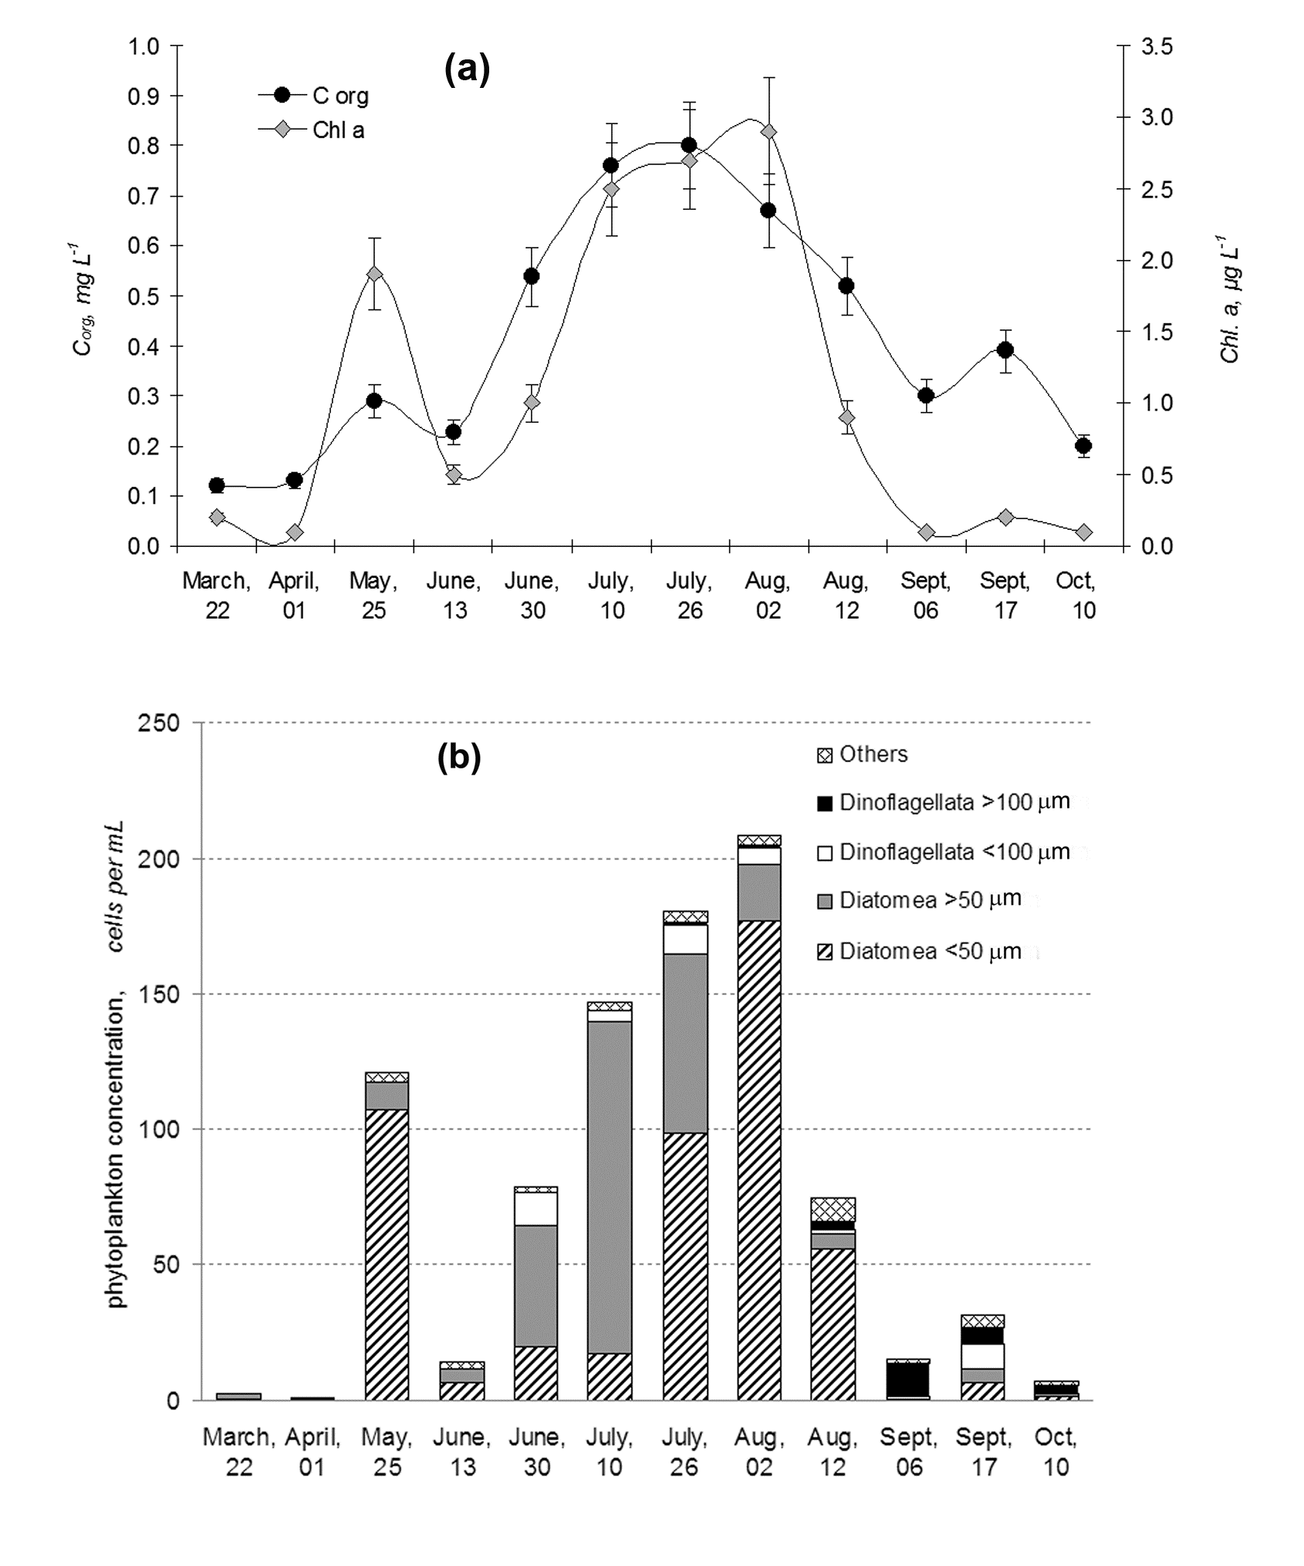
Fig. 2 Seasonal dynamics of major seston characteristics, station D-1 (2000-2008): (a) C_{org} and Chl a concentration; (b) key phytoplankton taxa concentration

Seasonal and diel dynamics of Calanus glacialis vertical distribution
The annual dynamics of stage structure and preferable water layers occupied exhibited well-expressed seasonal patterns in the upper 0-65 m water layer (Fig. 3). The naupliar stages are the most abundant in the end of May through June in the upper water layers (0-25 m), and they are substituted here gradually by CI-CIII moulting copepodites (Fig. 4a). The latter disappear from plankton by July. At the deep station (D-3) this happens earlier. The CIV copepodites prevail through the rest of summer and autumn periods, inhabiting mostly layers beneath 25 m. Their impact decreases by appearance of CV and CF developmental stages from November through March. In April proportion of CIV increases again, but mostly due to disappearance of CV and females. The only stages presented in the population year round are CIV-CVI (females), which concentrate in the layers beneath 25 m, especially beneath 50 m, at the deep station (Fig. 5). Thus, the vertical distribution of all copepodite stages depends on the season greatly with older stages inhabiting deeper layers as the water warms up during year.

ВАРИАНТ 1

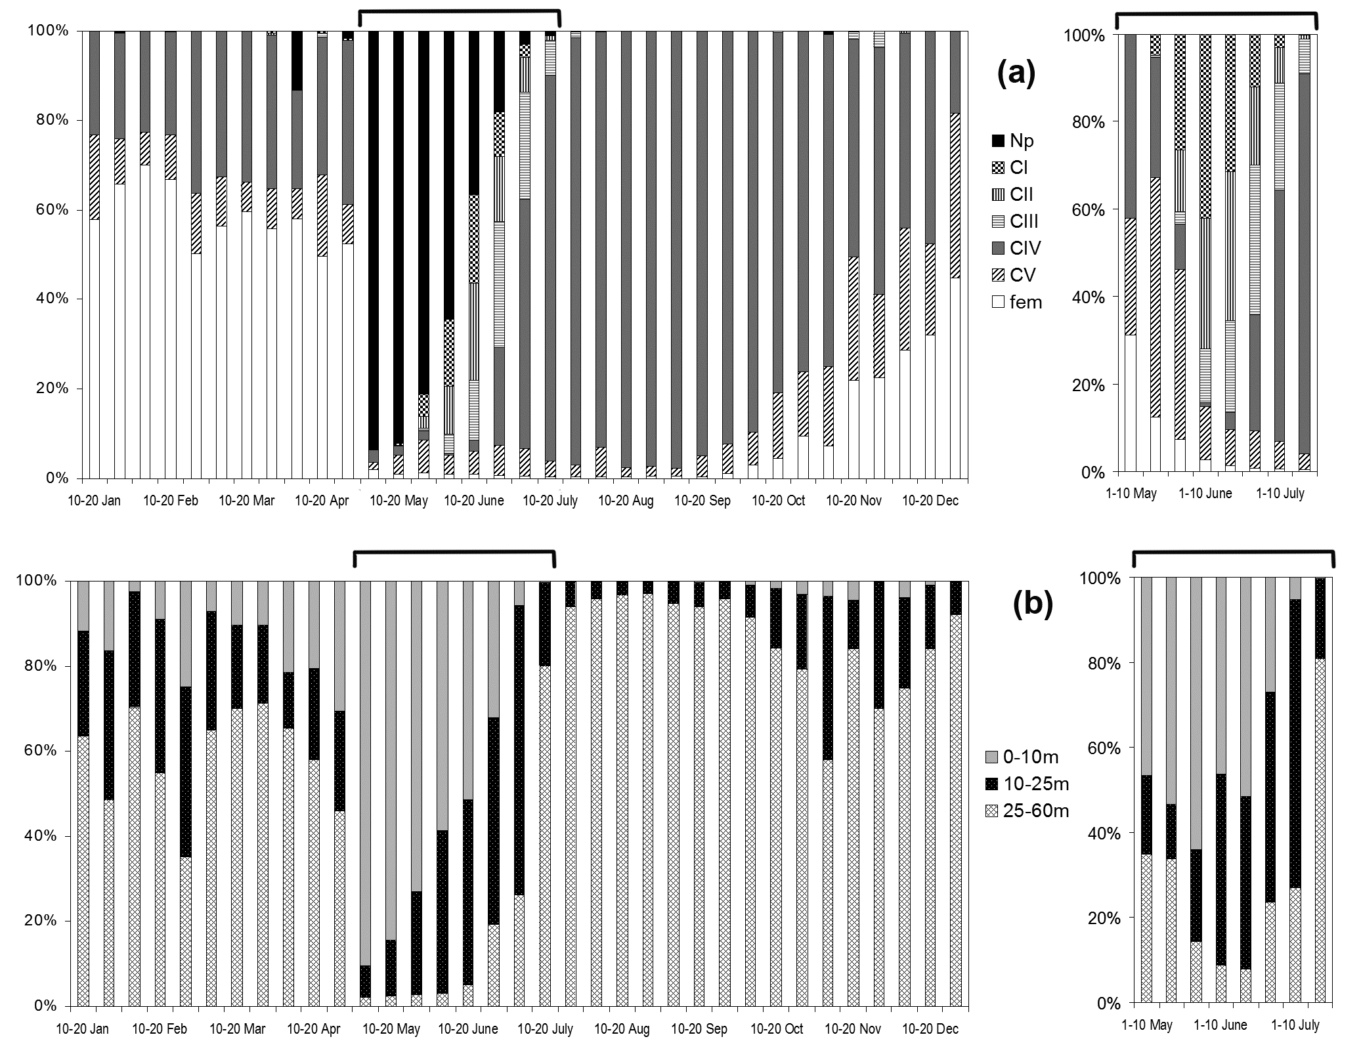
Fig. 3 Annual dynamics in vertical distribution of copepodite stages (a) and layers occupied (b) by Calanus glacialis on station D-1 (average for the period 1964-2007). Bars – decadal means; right inset – except naupliar stages. Np – nauplii; CI-CV – immature copepodites; fem – CF, females

ВАРИАНТ 2

Вариант 3
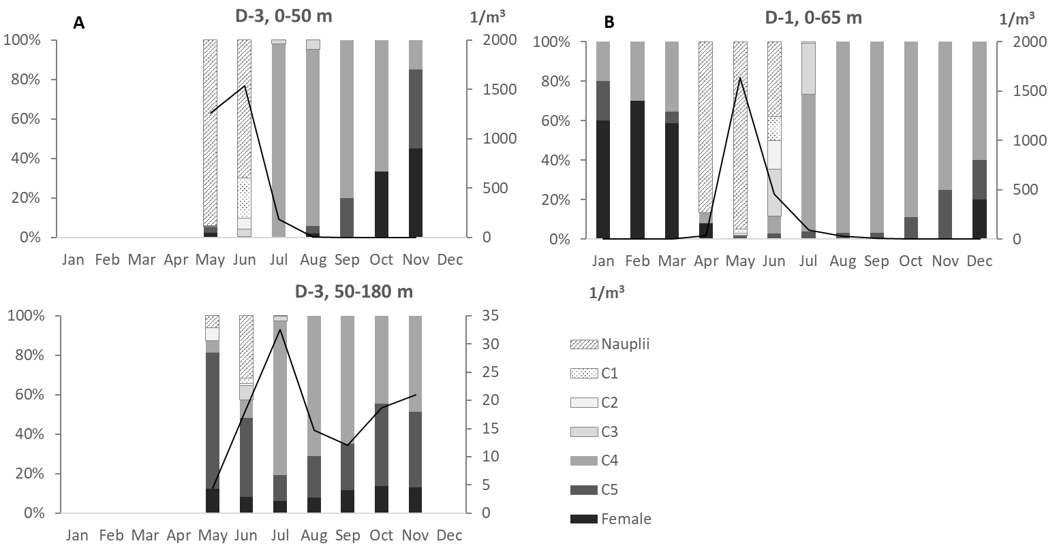

Рис. 3 Изменение состава популяции в течение года на глубоководной станции (А), на декадной станции (B). Сплошной линией обозначена суммарная плотность популяции. Левая ось ординат – доля конкретной стадии развития в популяции; правая – плотность популяции.

Ещё два рисунка по вертикальному распределению.
Это наследие Игоря ВАРИАНТ 3
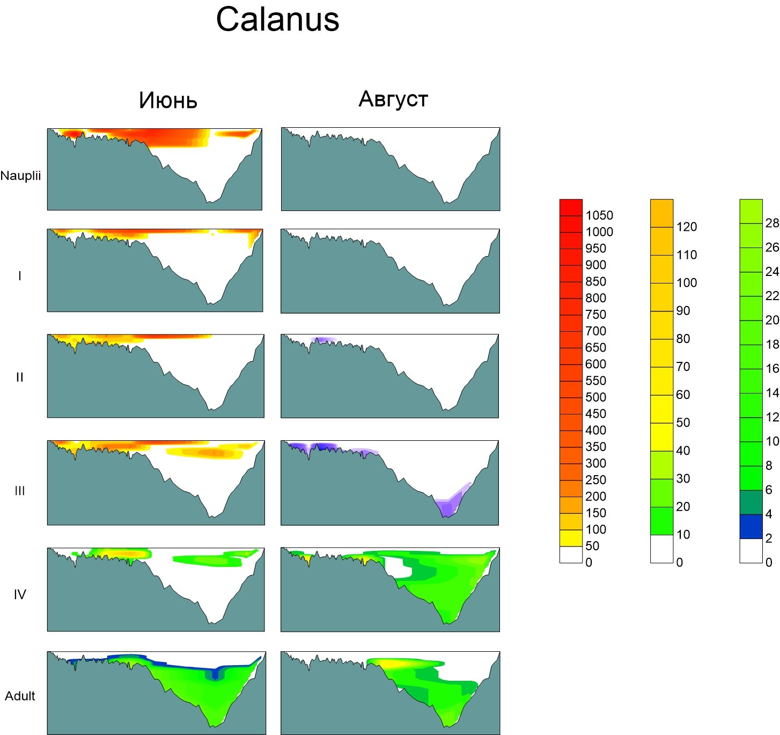

Это новый рисунок от Коли ВАРИАНТ 4

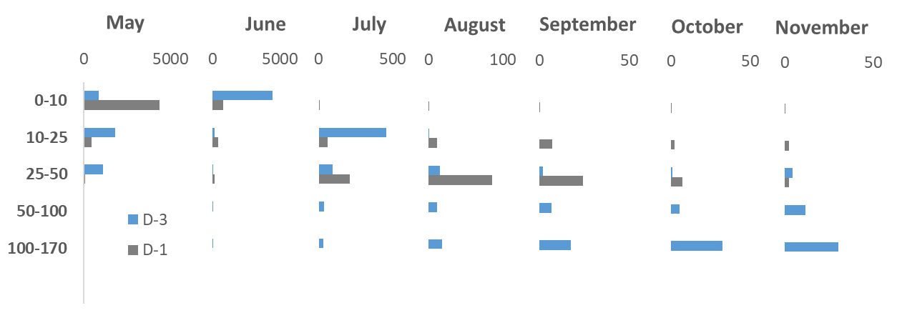
Рис. 3. Вертикальное распределение Calanus на глубоководной (D-3) и мелководной (D-1) станциях в течение теплого периода (когда отбирали пробы на D-3).

Diel vertical distribution dynamics changes greatly both in early and late summer (early July and the end of September, respectively) for certain copepodite stages. The most pronounced diel vertical migrations (DVM) are observed for naupliar and CIV copepodites in early July (Fig. 5a) and for CIV copepodites in the end of September (Fig. 5b). The migrations take place in the upper water layer, 0-25 m, in both seasons, when animals move to upper layers in the night time and descend to deep layers during daylight period. The variability of diel vertical distribution of the other copepodite stages is insignificant to conclude DVM presence.
The dataset on long-term observations allowed recalculating the critical (highest) temperature, when C. glacialis started their migration down to deep layers after surface water temperature has increased. Surprisingly, naupliar and young copepodites (CI-CIII) exhibited high tolerance to wide temperature range, with the highest temperatures reached +7.7°C. The CIV and CV copepodites were less tolerant and left the surface layers when the water temperature exceeded +4°C. The females were the most vulnerable and preferred the narrow range of the water temperatures as -1.5 to +1.5°C.

Fig. 5 Daily vertical distribution of different developmental stages of Calanus glacialis on diel stations, D-2: (a) early summer, July, 1-2, 1998; (b) late summer, Sept, 27-28, 1997. Bars – daily mean; vertical lines – daily variability

Modeling
Здесь написать о том, что длительные наблюдения на Д-1 прекрасны, но глубина 65 м может казаться недостаточной для того, чтобы с уверенностью судить о процессах, происходящих в более глубоководных частях залива. Для этого провели верификацию данных Д-1 с Д-3:
Если рассмотреть сезонный ход ССА1 и ССА2 (см. ниже), то становится более или менее видно, что на обеих станциях динамика похожа. То есть материал обеих станций показывает некую общую картину.
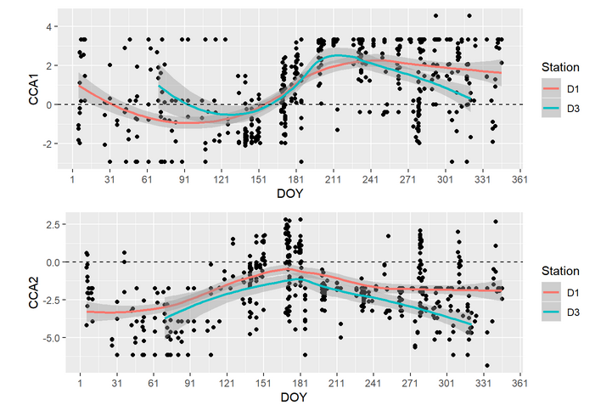
Рис. 4. Верификация Д-1 по Д-3

Далее работали уже с материалом Д-1, поскольку тут ряд наблюдений и частота гораздо выше.
Полученная ординация позволяет выделить четыре “состояния” в популяции:
- Условия, соответствующие I квадранту: Средняя глубина, Высокая соленость, высокая температура, среднее количество хлорофилла.
- Условия, соответствующие II квадранту: Малая глубина, Низкая соленость, Высокая температура и много хлорофилла.
- Условия, соответствующие III квадранту: Средняя глубина, высокая соленость, низкая температура и средняя концентрация хлорофилла.
- Условия, соответствующие IV квадранту: Большая глубина, Высокая соленость, низкая температура, и низкое содержание хлорофилла.

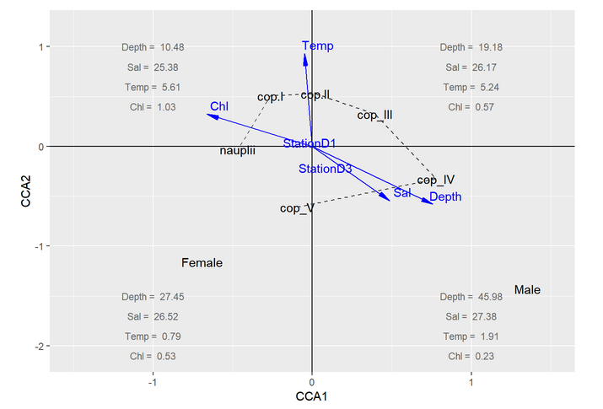
Рис. 5а. Ординация 1
Ординация стадий жизненного цикла, как мне кажется, очень закономерно связана с этими условиями и, как я понимаю, отражает характер миграций в онтогенезе. Самая ранняя стадия (науплиусы) наиболее обильны на границе II и III квадрантов. Они связаны с повышенной концентрацией хлорофилла, но избегают высоких температур. Следующие стадии, видимо, откармливаются в теплых нажористых мелководьях (III квадрант). А далее, по мере взросления, они уходят все глубже в голодные, но приятно холодные условия, соответствующие IV квадранту. Граница между IV и III квадрантами соответствует переходу от глубоководной бескормицы к более поверхностной обильной пищей, но все еще холодной среде. Здесь обильны сop.V и самки.
По-моему, эта картинка говорит, что есть “теплый” хлорофилл, на поверхности, с ним связаны cop.I. Он маркируется положительными значениями ССА2 и отрицательными значениями ССА1. Это состояние очень короткое, наблюдается в где-то на 150-й день года (см. ниже). Есть еще и “холодный” хлорофилл (отрицательные значения ССА1 и отрицательные значения ССА2). С этим хлорофиллом связаны самки, но не самцы (!) и cop.V. Видимо, метаморфоз происходит в этих условиях, после чего самки дают науплиусов, которые поднимаются на поверхность пожрать. Обилие науплиусов видимо зависит от хлорофилла, а не от температуры (они около 0 по ССА2). Самцы же уходят в холодное, глубинное, голодное небытие. Популяция живет на “холодном” хлорофилле от 50 до 150 дня.
Вот еще одна визуализация. По-моему, довольно удобная. Положение дня взятия пробы относительно начала года, которое совпадает с его концом, можно охарактеризовать следующей величиной
Dayposition=−cos(2πDOY365)
Эта величина близка к -1 когда DOY (Day of Year) близок к 1 января (начало января, конец декабря) и равна 1 когда DOY максимально удален от него (разгар лета). Тогда можно построить ординацию описаний в осях ССА и оценить как связано положение точки в ординации с временем года. Видно, что в III и IV квадрантах популяция находится более или менее зимой, а в I и II квадрантах преимущественно летом. При этом максимальная численность популяции наблюдается как раз в районе близком ко II квадранту (то есть когда много хлорофилла).
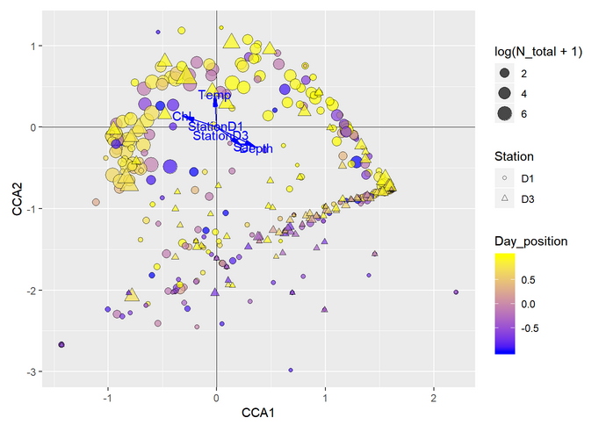
Рис. 5б. Ординация 2
Prosome length and biochemical parameters
The cephalosome length in elder copepodites (CIV-CV) and females (CF) did not differ through all the spring period (Table 3). The same was observed for L_{c}/W ratio, however, with some exceptions for CV copepodites. Thus, copepodites sampled in upper (10-25 m) and deeper (25-100 m) layer in in 6--12 weeks after the ice melt, differed significantly in L_{c}/W ratio, when more elongated specimens (higher L_{c}/W ratio) tended to occupy deeper layers.

Table 3. Cephalosome length and cephalosome length/width ratio (L_{c}/W) of Calanus glacialis in spring—summer period of 2005—2008, mean ± SD (Student t-test, p < .05 are highlighted in bold). Asterisks* indicate the data cited under Ashjian et al. 2003; n – number of studied specimens (similar for L_{c}/W ratio)
Period | Stage | Cephalosome length, mm |  |  |  |  | L_{c}/W ratio
Period | Stage | 0-25 m | n | 25-100 m | n | p | 0-25 m | 25-100 m | p
solid ice | CIV | 2.34 ± .19 | 14 | 2.39 ± .10 | 16 | 0.71 | 4.13 ± .28 | 4.38 ± .18 | 0.37
(February–March) | CF | 4.09 ± .09 | 11 | 4.00 ± .22 | 22 | 0.34 | 3.79 ± .17 | 3.79 ± .26 | 0.58
1–2 weeks before ice melt | CIV | 2.35 ± .14 | 10 | 2.33 ± .08 | 13 | 0.45 | 4.47 ± .21 | 4.69 ± .28 | 0.09
(April, 1–20) | CF | 4.09 ± .21 | 13 | 4.05 ± .13 | 41 | 0.11 | 3.74 ± .20 | 3.83 ± .21 | 0.84
4 weeks after ice melt | CV | 3.46 ± .20 | 51 | 3.43 ± .21 | 102 | 0.23 | 4.03 ± .04 | 4.14 ± .03 | < 0.01
(May, 20–June, 10) | CF | 4.10 ± .17 | 25 | 4.08 ± .18 | 68 | 0.47 | 4.54 ± .18 | 3.84 ± .03 | < 0.01
6 weeks after ice melt | CV | 3.43 ± .17 | 82 | 3.40 ± .19 | 57 | 0.14 | 3.46 ± .04 | 3.83 ± .03 | < 0.01
(June, 1–June, 20) | CF | 4.16 ± .12 | 21 | 4.07 ± .15 | 21 | 0.09 | 3.85 ± .14 | 3.72 ± .22 | 0.27
8 weeks after ice melt | CIV | 2.40 ± .11 | 60 | 2.41 ± .22 | 29 | 0.37 | 4.52 ± .02 | 4.30 ± .03 | < 0.01
(June, 10–June, 30) | CV | 3.36 ± .16 | 23 | 3.40 ± .18 | 146 | 0.15 | 3.00 ± .37 | 3.96 ± .03 | < 0.01
 | CF | 4.12 ± .13 | 14 | 4.11 ± .12 | 23 | 0.77 | 3.82 ± .15 | 3.71 ± .04 | 0.99
10–12 weeks after ice melt | CIV | 2.35 ± .10 | 186 | 2.38 ± .13 | 145 | 0.57 | 4.61 ± .02 | 4.40 ± .02 | < 0.01
(June, 20–July, 30) | CV | 3.46 ± .15 | 33 | 3.40 ± .17 | 239 | 0.49 | 3.58 ± .04 | 4.08 ± .02 | < 0.01
 | CF | 4.11 ± .10 | 12 | 4.08 ± .10 | 35 | 0.14 | 3.71 ± .09 | 3.83 ± .09 | 0.14
average (by layers) | CIV | 2.37 ± .14 | 270 | 2.39 ± .12 | 203 | 0.76 | 4.58 ± .03 | 4.40 ± .02 | < 0.01
 | CV | 3.43 ± .18 | 189 | 3.41 ± .19 | 544 | 0.63 | 3.63 ± .08 | 4.07 ± .01 | < 0.01
 | CF | 4.09 ± .17 | 96 | 4.07 ± .12 | 210 | 0.48 | 3.83 ± .48 | 3.80 ± .22 | 0.56
average  (pooled data) | CIV | 2.38 ± .13 | 473 | *2.36 ± .03 |  |  | 4.50 ± .29
 | CV | 3.41 ± .18 | 733 | *3.21 ± .03 |  |  | 3.95 ± .49
 | CF | 4.08 ± .15 | 306 | *3.87 ± .02 |  |  | 3.81 ± .31

Fig. 6 Spring and early summer dynamics in L_{c}/W ratio in Calanus glacialis (2005-2008): (a) CIV copepodites; (b) CV copepodites; (c) CF, females. Bars – mean ± SE; vertical lines – max and min values. For the period definition please refer to Table 3. 0-25 and 25-65 – sampling water layers, m

Seasonal dynamics of organic compounds and lipids
Elder copepodite stages (CIV-CF) of Calanus glacialis exhibited strong seasonal dynamics of C_{org} content, C:N ratio and lipid characteristics, such as total absolute and relative lipid content and relative content of lipid classes. The absolute content of C_{org} varied significantly in 1.5 times through the year with the highest values observed in late autumn (October), and the lowest, in late spring period, May (Fig. 6). The same was found for C:N ratio, which might reach more than 10 in October, indicated high relative content of lipids. The last was proved by data on the total lipid content, both absolute (Table 4) and relative (Fig. 6a), which exhibited the same dynamics as absolute C_{org} content and C:N ratio. Most of the data on relative content of the major lipid classes, wax esters (WE), tryacilglycerols (TAG) and phospholipids (PL), fitted nicely the life history, when nearly all the copepodites sampled in the deep water layers (25-100 m) were characterized by elevated amount of storage lipids (WE and TAG) and low relative content of structural lipids (PL) (Fig. 6b). The opposite pattern with some exceptions was observed for the upper water layers (0-25 m). However, some data were quite surprising. Thus, two exceptions was found, the first one for CV copepodites sampled in the upper water layers and for deep-dwelling CIV copepodites, both in March, as well as opposite pattern for CV copepodites in July (Fig. 6b). The only CIV copepodites were characterized by elevated amount of structural lipids, up to 73%, through all the studied period. All the other copepodite stages, sampled in deep water layers, tended to increase the amount of storage lipids before winter and kept this ratio until the productive season started.
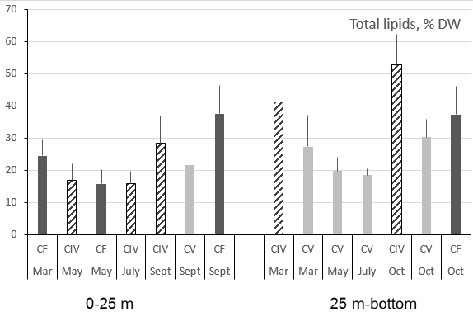 | 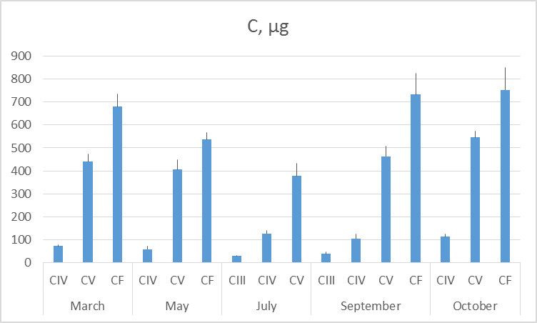
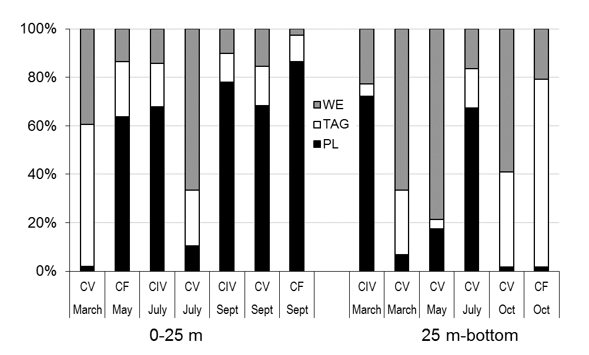 | 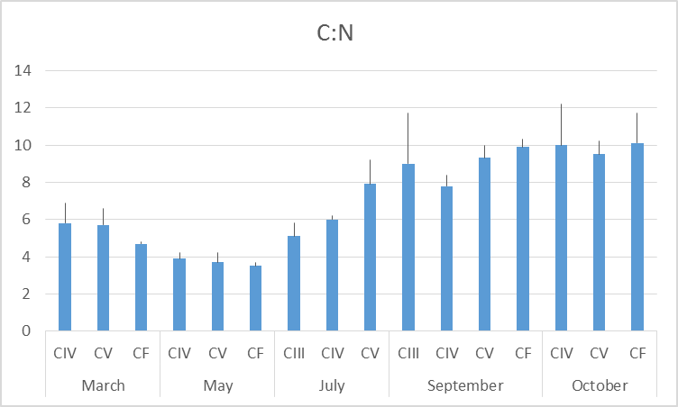
Fig. 6 Seasonal dynamics in lipid content in elder copepodites (CIV-CV) and females (fem) of Calanus glacialis. WE – wax esters; TAG – tryacilglycerols; PL – phospholipids. 0-25 m and 25-100 m – sampling layers + Organic C and C:N ratio.

Table 4. Fatty acids and major FA indices of Calanus glacialis in the White Sea, mean ± SD. nd -- not detected; 0.0 < 0.05%.

Season | March | March | March | May | May | May | July | July | Sept | Sept | Sept | Oct | Oct | Oct
Stage | CIV | CV | CF | CIV | CV | CF | CIV | CV | CIV | CV | CF | CIV | CV | CF
16:1(n-7) | 14.3 | 0.0 | 11.3 | 11.9 | 10.5 | 2.4 | 8.5 | 0.0 | 1.2 | 15.8 | 19.0 | 16.0 | 13.0 | 0.6
18:1(n-9) | 0.0 | 0.0 | 0.0 | 0.0 | 0.0 | 0.0 | 0.0 | 0.0 | 0.0 | 0.0 | 0.0 | 0.0 | 0.0 | 0.0
18:1(n-7) | 0.8 | 5.0 | 5.5 | 0.0 | 3.4 | 0.0 | 1.2 | 9.9 | 0.9 | 4.2 | 6.5 | 4.6 | 15.2 | 2.0
20:1(n-9) | 1.4 | 1.8 | 4.4 | 3.0 | 1.6 | 0.6 | 0.0 | 9.1 | 17.2 | 16.7 | 5.8 | 1.7 | 4.3 | 3.1
20:1(n-7) | 0.0 | 1.5 | 1.4 | 0.0 | 0.9 | 0.0 | 1.2 | 1.5 | 36.1 | 1.7 | 0.0 | 4.2 | 0.0 | 0.0
22:1(n-11) | 11.3 | 0.0 | 7.9 | 0.0 | 0.9 | 31.8 | 1.2 | 3.4 | 0.2 | 0.6 | 2.5 | 2.1 | 6.5 | 18.2
22:1(n-9) | 2.4 | 0.0 | 1.3 | 0.0 | 0.0 | 6.8 | 0.0 | 0.0 | 35.0 | 4.9 | 0.6 | 0.4 | 0.0 | 8.3
16:2(n-4) | nd | nd | nd | nd | nd | nd | nd | nd | nd | nd | nd | nd | nd | nd
16:4(n-1) | nd | nd | nd | nd | nd | nd | nd | nd | nd | nd | nd | nd | nd | nd
16:2(n-7) | nd | nd | nd | nd | nd | nd | nd | nd | nd | nd | nd | nd | nd | nd
18:4(n-3) | 0.0 | 0.0 | 0.0 | 0.0 | 0.0 | 0.0 | 0.0 | 2.3 | 0.0 | 0.0 | 0.0 | 1.3 | 0.0 | 0.0
20:5(n-3) | 7.5 | 1.6 | 1.5 | 3.0 | 0.8 | 11.6 | 0.0 | 1.9 | 0.0 | 0.6 | 0.9 | 3.8 | 4.3 | 12.1
22:6(n-3) | 0.0 | 0.0 | 0.0 | 0.0 | 2.8 | 23.3 | 3.7 | 17.5 | 0.0 | 5.9 | 1.5 | 5.0 | 4.3 | 0.0
ΣSFA | 35.7 | 50.2 | 52.5 | 46.3 | 65.7 | 9.6 | 69.5 | 53.2 | 2.6 | 30.0 | 36.5 | 34.0 | 34.8 | 15.5
ΣMUFA | 45.7 | 44.2 | 34.9 | 50.7 | 22.5 | 45.3 | 20.7 | 24.0 | 97.2 | 58.3 | 60.0 | 48.7 | 52.2 | 65.6
ΣPUFA | 18.6 | 5.6 | 12.6 | 3.0 | 11.7 | 45.1 | 9.8 | 22.8 | 0.2 | 11.7 | 3.5 | 17.2 | 13.0 | 18.9
(n-3)/(n-6) | 10.2 | 5.4 | 7.6 | 0.0 | 0.7 | 27.5 | 7.0 | 19.0 | 0.0 | 2.8 | 0.0 | 5.8 | 5.0 | 2.3
UC | 0.23 | 0.06 | 0.14 | 0.03 | 0.13 | 0.82 | 0.11 | 0.30 | 0.01 | 0.13 | 0.04 | 0.21 | 0.15 | 0.23
DHA/EPA | 0.0 | 0.0 | 0.0 | 0.0 | 3.5 | 2.0 | 0.0 | 9.2 | 0.0 | 10.7 | 1.8 | 1.3 | 1.0 | 0.0
16:1(n-7)/16:0 | 0.7 | 0.0 | 0.5 | 2.0 | 1.1 | 0.5 | 0.7 | 0.0 | 0.8 | 0.9 | 0.8 | 0.8 | 0.6 | 0.2
Total lipids, μg | 50±12 | 120±43 | 166±34 | 10±3 | 80±17 | 85±23 | 20±5 | 70±17 | 30±9 | 100±16 | 275±65 | 60±11 | 165±30 | 280±66

Seasonal feeding dynamics
The food spectra of Calanus glacialis was studied experimentally and by FA analysis. The selectivity ratio, calculated for the most abundant phytoplankton taxa, revealed significant food preferences. In March, females preferred to consume small Pseudonitzschia and Chaetoceros species (cells less than 50 μm diameter), Thalassionema spp. and Thalassiosira spp., even when the total phytoplankton concentration was relatively low (Fig. 2b). In June, CIII and CIV copepodites were characterized by nearly the same food spectra, consumed Pseudonitzschia and Chaetoceros species (cells less than 100 μm diameter), Thalassionema spp., Leptocylindrus spp. and tintinnids (Protista). The CV copepodites consumed the same species except Leptocylindrus spp. In September, the studied developmental stages fed on small diatoms (cells less than 50 μm diameter). Most of thecate dinoflagellate species, especially relatively big cells of Ceratium fusus, C. arcticum, Protoperidinium spp., were totally avoided by all the copepodite stages.
The analysis of marker FAs showed relatively low herbivorous ratios, such as ΣPUFA, (n-3)/(n-6), UC and 16:1(n-7)/16:0, for elder copepodites (CIV-CV) and females studied for different seasons (Table 4). No sign of major diatom FA (16:2(n-4), 16:4(n-7), 16:4(n-1)) was observed. Surprisingly, two cases of elevated dinoflagellate FA markers (DHA/EPA) were observed, both CV copepodites in July and September. Also, high content of SFA and extremely low UC index were observed for nearly all the studied stages through the season, with minor exceptions (females, May).
The absolute daily ration varied greatly even within one developmental stage through the season, with the absolute maximum for females in May (Fig. 7a). Opposite to, CV tended to start active feeding much earlier, in March (Fig. 7b), and still kept the feeding activity until October, but decreased it significantly in July and September. The CIV copepodites seemed to be the most active through the whole season, when both absolute and relative daily rations stayed the same and differed insignificantly (Fig. 7a, b). All the copepodites stopped feeding totally in October. The impact of C_{org}, consumed as Chl a, may reach up to 99% in total C_{org} in March and May, but was surprisingly low in July and September in all the studied stages varying from 35 to 50% (Fig. 7c).

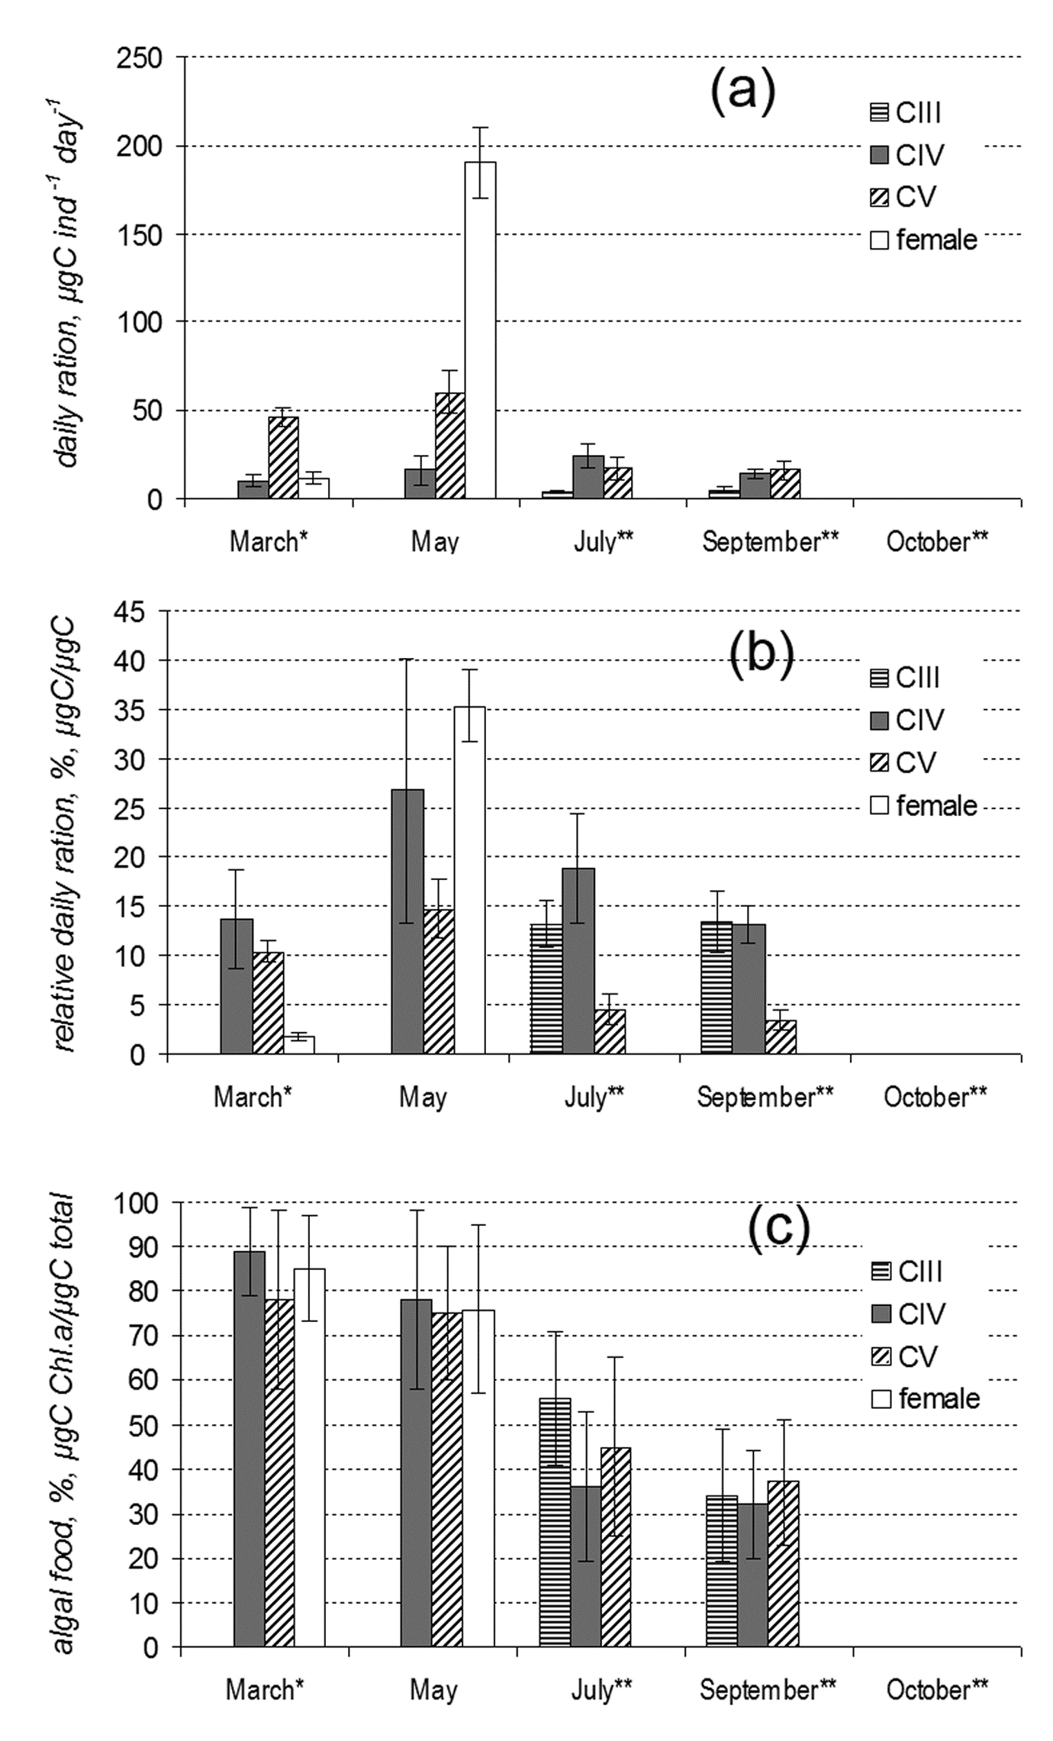 | Fig. 7 Seasonal feeding characteristics of Calanus glacialis in the White Sea: (a) absolute daily ration; (b) relative daily ration; (c) percent of algal food ingested, recalculated by impact of Chl a as C_{org} in total C_{org} consumed. One asterisk* - ice algae were suggested as food; two asterisks** - animals sampled in deep layers (25-100 m) were fed by surface seston

Early gonad development
In 2008 the feeding conditions in the field were quite restricted, when Chl a concentration did not exceed 0.5 μg L⁻¹ (Fig. 2a), but the females produced from 2 to 18 pellets per individual per day. The females, studied in March-April, 2008, were significantly divided into two groups. First one, constituting about 70% of total population, was formed by bright-coloured (“red”) animals, which had more developed gonads (ANOVA; F_{(1, 237)} = 19.99, p < 0.001). The gonad stage was also preconditioned by food presence (ANOVA; F_{(1, 237)} = 7.05, p < 0.01), and the starved animals had significantly less developed gonads compared to the fed ones (Fig. 8). However, the animal coloration and food presence impacted to the gonad stage independently (MANOVA; F_{(2, 235)} = 1.42, p = 0.24). The food presence has not any significant impact to the animal coloration after one month of total starvation (ANOVA; F_{(1, 237)} = 2.24, p = 0.14). Both L_{c} and L_{c}/W ratio did not depend nor on animal coloration (ANOVA; F_{(1, 237)} = 2.414, p = 0.12), neither on food presence (ANOVA; F_{(1, 237)} = 0.01, p = 0.92). The critical gonad stage is the third (G3); the starved animals hardly formed well-developed ovaries. However, the feeding on the natural phytoplankton assemblages during the month did not allow the fed females to start reproduction, and about 40% of them still had gonad stage G2. These females were mostly “pale” ones, constituting about 65% of all females of gonad stage G2. The “red” ones, which got the food supply, developed their gonads partially, about one third of their sampled population were still keeping stage G2, about 20% developed to stage G3, and about a half of them reached gonad stages G4 and G5. "Pale" females were quite inactive in gonad developing even in the food presence. Thus, about 50% of them were still at gonad stage G2, about 35% developed to stage G3, and only 15% of them reached gonad stages G4 and G5.

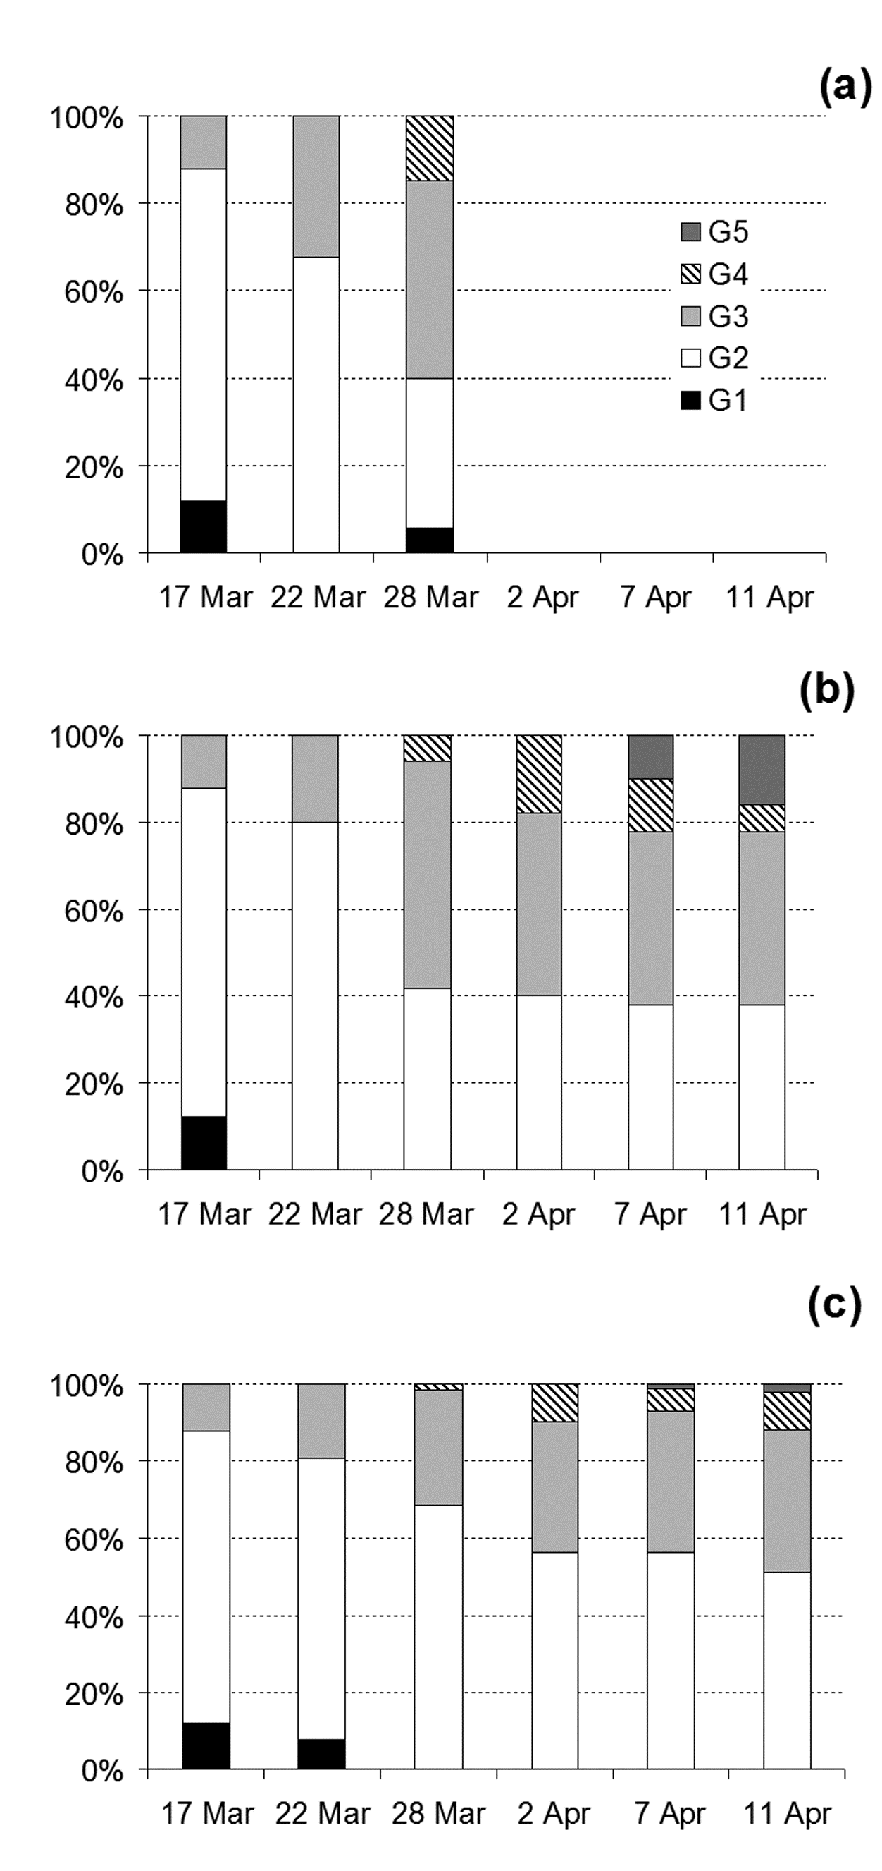 | Fig. 8 Early spring female gonad state dynamics in Calanus glacialis (station D-3, 2008): (a) - natural population, from 50 to 68 ind.; (b) - fed females (natural phytoplankton), 50 specimens individually; (c) - starved females, 202 ind. bulk. G1-G5 – gonad stages, accordingly to Table 2

DISCUSSION

The White Sea is a semi-closed sub-Arctic region, which exhibits the features of both Arctic and temperate waters and is characterized by the lower salinity ranging 25—28 psu (Berger et al. 2001). The seasonal dynamics of the water temperatures, especially in the upper, productive layers, as well as the seston/phytoplankton dynamics (Berger 2007; present study) impact significantly on the zooplankton species biology. The surface water temperatures may reach +20°C in the summer period, averages as +12…+14°C (Berger et al. 2003; present study), while the other sub-Arctic areas are characterized by significantly lower temperatures, which do not exceed +6…+8°C (Coachman and Aagaard 1974). Thus, the period of coincidence of high primary production and low temperatures in the White Sea is shortened greatly, when the surface layer water temperature increases up to +10°C in 6-8 weeks after the ice melt. The Arctic herbivores, inhabiting the White Sea, have to deal with such mismatch of the favorable conditions period length and duration of certain life stages. C. glacialis, nevertheless, evolved several specific features, which allow it to exist in the White Sea successfully.
The life cycle of Calanus glacialis in the White Sea is considered to be biennial (Prygunkova 1968, 1974), with possible third overwintering as a female stage (Kosobokova 1998, 1999). The species biology, including reproduction, feeding and lipid peculiarities, however, was described before in general terms with seasonal data missing, implying high similarity to the populations inhabiting other areas of the Arctic. Careful analysis of several particular features of species biology, presented in this study, allows us to conclude on significant differences in species ecology in the White Sea.
The principal scheme of C. glacialis in the White Sea was suggested by Prygunkova (1968, 1974) and specified by Kosobokova (1998, 1999). The reproduction takes place in May-June, when the females lay the eggs in the upper water layers, rich by phytoplankton. Naupliar growth and molt as well as reaching CIV copepodite stage occur during the first summer. The CIV copepodites store the lipids and winter until the next spring, when they molt to CV, store the lipids again and winter second time, molting to mature stages without any food supply, when they use storage lipids. The females, which have no possibility to finish the reproduction successfully in the third spring of the life history, can resorb the lipids and winter once more. This scheme fits nicely the principal “Calanus” life cycle pattern (Slagstad and Tande 1990; Arnkværn et al. 2005; Falk-Petersen et al. 2009). However, the present study reveals some special features of C. glacialis biology in the White Sea, which are, on the one hand, going in accord with the principal scheme of life cycle proposed before and, on the other hand, stating significant regional differences of this species comparing to the populations of the other Arctic areas.
Before we discuss life cycle of a specific organism let's make sure that we are speaking about this very species. We have no doubt the only C. glacialis species inhabits the White Sea, as it goes from significant similarity of the prosome length in the present study and data of the other authors (Ashjian et al. 2003), as well as previous species reviews (Pertzova and Pantyulin 2005).
The wider temperature optima in early copepodite stages may be considered as the first adaptation of Calanus glacialis to unfavorable temperature conditions. The CI-CIII copepodites exhibit wide temperature optima, with the highest tolerant temperatures reaching +7.7°C, which is significantly higher comparing to the data presented for the other Arctic areas, with upper values of +2.75…+5°C (Hirche 1987; Tande 1988; Willis et al. 2006), where this species is described as an indicator of the cold Arctic water masses (Hirche et al. 1994; Auel and Hagen 2002; Head et al. 2003; Daase et al. 2007; Blachowiak-Samolyk et al. 2008). On the other hand, naupliar and elder copepodite stages, as well as females, are characterized by narrow temperature optimum range, however, reaching in some cases +6°C. Such narrow temperature optima for nauplii may be easily explained by short period of these stages presence in the sea, which coincides with the period of the lowest water temperatures in spring. However, the temperature preferences of CIV-CV copepodites and females are quite restricted, and temperature sensitivity of these stages is obvious, especially taking into account their nearly annual presence in plankton. Thus, when the surface waters begin to warm, the elder and mature copepodites descend to deeper layers, as it is described for the other C. glacialis populations (Madsen et al. 2001). We assume this makes possible to decrease the food competition between young and elder copepodites and thus impacts to the species success positively.
In spring, up to seventy-five percent of Calanus glacialis population in the White Sea concentrates in the upper productive water layer, 0-25 m. As it was described before, C. glacialis reaches CIV copepodite stage, starting from the egg during the first “summer” (e.g. spring and summer period) of its life cycle (Prygunkova 1974; Kosobokova 1998, 1999). It takes about 8-10 weeks to reach CIV copepodite stage from the egg (present study, Fig. 4a), but molting to CIV stage coincides with significant increase of the upper water layer temperatures. Meantime, CIV copepodites still need significant amount of food supply to store the lipids before the first winter (CIV). We tend to link the diel vertical migrations (DVM) in early and late summer, which are observed exclusively for CIV stages, by lack of food resources in deep layers, high energy requirements and thus by attempt of these copepodites to obtain necessary amount of energy. Feeding activity patterns and food spectra may prove such suggestion. The feeding activity of CIV copepodites stays nearly the same from March through September, which may indicate high-energy requirements for CV molting and overwintering as CIV copepodites. The FA analysis reveals high relative amount of both bacterial and dinoflagellate fatty acids, which may be consumed as dinoflagellates and particulate organic matter during second half of the summer period. The last is also supported by significantly low percentage of Chl a consumed after the spring period ends. Omnivory and even predatory is described for arctic Calanus species, C. glacialis and C. finmarchicus (Perueva 1977a; Nejstgaard et al. 1997; Levinsen e al. 2000; Sato et al. 2002; Stevens et al. 2004 a, c; Basedow and Tande 2006; Castellani et al. 2008), with high impact of algal diet in a spring bloom conditions (Smith and Lane 1988; Koski 2007; Saage et al. 2008; Søreide et al. 2008) and significant amount of dinoflagellates in the diet (Madsen et al. 2001; Turner et al. 2001). The dynamics of relative total lipid content as well as high amount of structural lipids in CIV through all the year also exhibit high activity of this copepodite stage, comparing to undoubtedly “normally” diapausing CV copepodites and females. Such activity of CIV copepodites lays out of the scheme described for the high Arctic, when the feeding stops after the spring bloom ends (Levinsen et al. 2000). All these facts allow us concluding quite unfavorable conditions especially for CIV and, possibly, for CIII, copepodites through the summer period, which are, nevertheless, compensated by high food plasticity and diel vertical migrations. The daily feeding dynamics was observed in CIV copepodites of C. glacialis in the White Sea in late August also by Perueva (1977b, 1984) and in higher latitudes by Båmstedt (1984) and Cottier et al. (2006). High food plasticity of CIV copepodites of C. glacialis in the White Sea, when this species consumes dinoflagellates and even naupliar stages of copepods, was also described before (Perueva 1977a). Our data on experimentally obtained data on food spectra and marker FAs allow supposing that not only CIV, but also CV copepodites and females may consume non-algal food, when the algal resources are lacking, and thus complete the lipid storage successfully. Kosobokova (1990) supposed that energy accumulation in C. glacialis takes place in the spring and summer of the 2nd year; however, we tend to prolong this period in the White Sea for at least until the end of September for CIV copepodites.
To our opinion, the pattern of CV life stage duration and biology peculiarities of this developmental stage in the White Sea also differ from “classical” model. It was proposed that CIV copepodites molted to CV and stored the lipids during the second spring/summer and molted to mature stages during second winter (Prygunkova 1974; Kosobokova 1998, 1999). The data on L_{c}/W ratio and lipid classes’ pattern in CV copepodites in late spring tend us to propose one more winter period for at least the part of CV population. As it appears, the “lower” population of CV consists of significantly elongated specimens, while the copepodites found in the upper water layers are characterized by significantly wider cephalosome with the same cephalosome length. Temperature may largely alter body volume (e.g. width) rather than body length, and lipids may reflect more direct effects of food supply in Calanus species (Escribano and McLaren 1992). The ratio of structural vs. storage lipids in CV in July exhibits reverse pattern, when active animals with high relative structural lipid content occupy deeper layers. We suppose the molting from CIV to CV takes place in the deeper layers, where the molting specimens have more chances to escape visual predator’s pressure, e.g. adult herring, which concentrates during this period in the surface layers (Prygunkova 1985). The DVM of naupliar stages may be easily explained also by visual predators’ pressure, as it is known Calanus nauplii are one of the major food resources for the larvae of the White Sea herring (Prygunkova 1985). The midnight sun diel vertical migrations affected by predators’ presence were also found for C. glacialis in Baffin Bay, 75°00’N (Sameoto 1984) and in Barrow Strait, 74°30’N (Fortier et al. 2001). Meantime, the upper layers are occupied by already wintered CV, which store the lipids for the next winter of maturation, feeding in food-rich layers. It seems discussible that CIV specimens, molted in the end of spring to CV, have a chance to store essential amount of lipids to perform winter molt to mature stage and start to form gonads, which is extremely expensive energy process (Sargent and Falk-Petersen 1988; Mayor et al. 2009). After CV store essential amount of lipids they descend to deep layers (Kosobokova 1998, 1999; present study), as it is observed in the other Arctic areas (Basedow et al. 2004).
Prolonged period of CV to female molting (Kosobokova 1998, 1999) as well as possible food insufficiency during springtime, which appears as a result of short period of cold upper waters and high temperature vulnerability of CV copepodites and females (present study), lead to conclude second possible overwintering as a female stage in Calanus glacialis in the White Sea. Suggested by Kosobokova (1998, 1999), this was significantly proved by two female cohorts observed in the early spring, which differed in specimen coloration and gonad development rates (present study). As with CV copepodites, we assume the females, which molt from CV the latest or are exposed to food insufficiency, may winter once more. The gonad development process in females is highly food-dependent, as it is showed here and by the number of publications (Tande et al. 1985; Hirche and Bohrer 1987; Kosobokova and Hirche 2001; Hirche and Kwasniewski 1997). Opposite to, some authors argue for food-independent gonad maturation in C. glacialis (unpublished data by Conover & Harris in Conover 1988; Smith 1990; Hirche and Kattner 1993; Niehoff et al. 2002), as it is observed in C. hyperboreus (Pasternak et al. 2001; Falk-Petersen et al. 2009). However, we assume that both energy resources play significant role in C. glacialis population in the White Sea, when early gonad development may occur using the lipid storage. However, females essentially need the food supply on the latest stages of egg forming and egg releasing to sustain the population, as it was shown for Calanus species in the Arctic (Barthel 1990; Hirche 1989; Hirche et al. 1991; Richardson et al. 1999; Seuthe et al. 2007; Madsen et al. 2008). The dynamics of lipid classes and total lipid content as well as feeding activity in females exhibits strong seasonal changes. The females are supposed to be active in May and even in September in the upper water layers, while they are characterized by low proportion of phospholipids comparing to the storage lipids in October in deep layers. The female activity in May is understandable, since during this period the reproduction and active feeding take place in the upper water layers. The inactivity of the females and CIV-CV copepodites in October has also no wonder, when the copepods are ready for winter and storage lipids play significant role (Hagen 1999; Hagen and Auel 2001; Scott et al. 2002). The most interesting data are obtained for September. Comparing the ratio of structural lipids between elder copepodite stages, CIV-CF, in the upper water layers, one can easily recognize the same pattern, when structural lipids play much role than storage lipids, the opposite pattern may be found for the copepods sampled in deep water layers in October. We assume September as a period of activity for those copepodites, which still have to store energy (lipids) before the winter comes. High feeding activity through summer was observed for C. glacialis/marshallae in Chukchi and Beaufort seas (Plourde et al. 2005).
To summarize, we propose that Calanus glacialis population inhabiting the White Sea employs complimentary biennial life cycle with possible prolongation up to three-four years (Fig. 10). The reproduction occurs in May-June; and it takes about 8-10 weeks to reach CIV copepodite stage. The scarcity of food resources due to warming of the productive upper layers evolves wider temperature optima in CI-CIII copepodites. High food plasticity, e.g. omnivorous feeding, is usual for elder copepodite stages, CIV-CF, in the period of food insufficiency. CIII and CIV copepodites perform diel vertical migrations to the upper water layers with well-expressed daily feeding dynamics at least in early and late summer to molt (CIII) and store significant amount of lipids (CIV) to winter successfully. The feeding activity of CIV copepodites stays high from March through September, as well as high relative amount of structural lipids, which allows us comparing this strategy with the patterns observed for some Antarctic species, which stays active during the austral winter (Kattner et al. 1994; Kattner and Hagen 1995; Albers et al. 1996; Atkinson 1998). The CV copepodites, which have a chance to molt in early spring from CIV and to store the lipids during spring phytoplankton bloom, which occurs in May-June, descend to deep water layers and molt to mature stages, females and males, during next winter on lipid resources. Those CV copepodites, which molt the latest, store the lipids and winter as the same developmental stage, getting the chance next spring. The lipid resources may support the early gonad development in females, but the last ones are highly food-dependent to form ripe gonads and to lay eggs successfully. Those females, which do not reproduce during first “female” spring, due to temperature increase (Kosobokova 1999; Niehoff and Hirche 2005) or food insufficiency, may resorb the gonads back to lipid drop and winter once more.
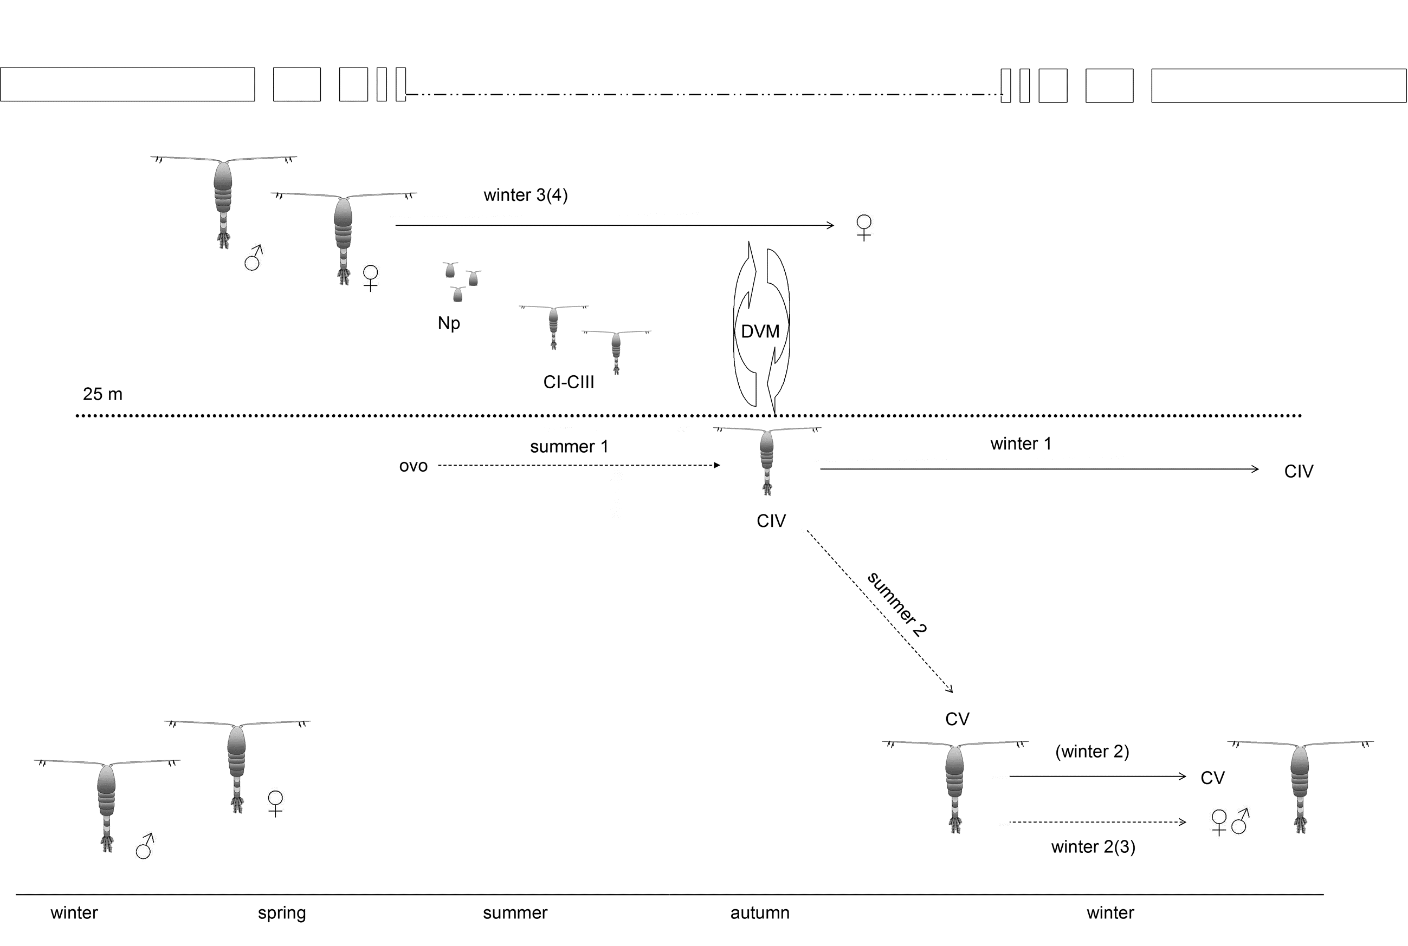
Fig. 9 Scheme of Calanus glacialis life cycle in the White Sea (compilation of original results and data by Prygunkova 1974; Kosobokova 1998, 1999). Np – naupliar stages; CI-CV – copepodite stages; dotted lines – molt periods; straight lines – wintering without molt; DVM – diel vertical migrations, late summer period (early summer DVM are not shown); titles and numbers in the brackets indicate possible, but non-obligatory events. Note: the wintering of all diapausing copepodite stages takes place deeper than 25 m depth

The adaptations of the life cycle of Calanus glacialis to unfavourable summer conditions in the White Sea allow us assuming local ecotype of this species in the studied area. The population of C. glacialis in the White Sea is isolated from the other Arctic areas by the southern Barents Sea, where C. finmarchicus dominates (Pertzova and Pantyulin 2005). The existing as an isolated population for the last 5,000 yrs allows C. glacialis evolving special adaptations and peculiarities of the life cycle strategy in the White Sea. Discussing possible impact of the global climate change (Beaugrand 2003; Carmack et al. 2006; Carmack and Wassmann 2006) to C. glacialis population in the White Sea we assume female reproduction period as the most vulnerable for the species success. The early ice melt in spring may lead to mismatch between the female readiness to start reproduction and spring phytoplankton bloom, as it is discussed by number of authors (Falk-Petersen et al 2007; Green and Pershing 2007). However, in the White Sea C. glacialis may get second chance by the cohort of “second-winter” females, which may constitute up to 30% of female population. Wider temperature optima in CI-CIII copepodites and high food plasticity in elder copepodites may also impact positively to the species survival. However, careful genetic analysis and comparison of the White Sea C. glacialis population to the populations inhabiting the other Arctic areas are essential.

ACKNOWLEDGEMENTS
The present study was supported by EUR-OCEANS (Network of Excellence funded by the European Commission, contract 511106-2), Otto Schmidt Laboratory Fellowship (project OSL-07-11), НАША НОВАЯ ТЕМА, and Russian Foundation for Basic Researches, RFBR (projects N08-04-01691-a and 08-04-98843-p_sever_a). We are grateful to Prof. Ulrich Bathmann (AWI, IOW), Dr. Eva-Maria Noethig (AWI), Dr. Heidemarie Kassens (IFM-GEOMAR) for invaluable support; Dr. I. Primakov (ZIN RAS), Christiane Lorenzen (AWI), and Sandra Murawski (AWI) for the help in sampling and sample processing.

REFERENCES
Albers CS, Kattner G, Hagen W (1996) The composition of wax esters, tryacilglycerols and phospholipids in Arctic and Antarctic copepods: evidence of energetic adaptations. Marine Chemistry 55:347-358.
Arashkevich EG, Drits AV (1984) Experimental feeding in copepods Calanus helgolandicus and С. glacialis at various food concentrations. Oceanology 24:316-322. [In Russian with English abstract]
Arashkevich EG, Kosobokova KN (1988) To the problem of life-strategy of herbivorous copepods: Physiology and biochemical composition of the overwintering Calanus glacialis in starvation conditions. Oceanology 28:657-662. [In Russian with English abstract]
Arashkevich EG, Sergeeva OM (1991) Feeding rates of the White Sea copepod species Calanus glacialis on different phytoplankton species, its faecal pellet production rates and pellet sinking rates. In: Monitoring investigations of phytoplankton in the Baltic and other USSR seas. Gidrometeoizdat, Moscow, p. 285-294 [In Russian]
Arnkværn G, Daase M, Eiane K (2005) Dynamics of coexisting Calanus finmarchicus, Calanus glacialis and Calanus hyperboreus populations in a high-Arctic fjord. Polar Biology 28:528-538.
Ashjian CJ, Campbell RG, Welch HE, Butler M, Van Keuren D (2003) Annual cycle in abundance, distribution, and size in relation to hydrography of important copepod species in the Western Arctic Ocean. Deep-Sea Res I 50:1235-1261.
Atkinson A (1998) Life cycle strategies of epipelagic copepods in the Southern Ocean. J Mar Sys 15:289-311.
Auel H, Hagen W (2002) Mesozooplankton community structure, abundance and biomass in the Central Arctic ocean. Marine Biology 140:1013-1021.
Barthel KG (1990) Relationships of food uptake and body components of Calanus finmarchicus, C. glacialis and C. hyperboreus to particulate matter and water characteristics in Fram Strait. Polar Biol 10:343-350.
Basedow SL, Eiane K, Tverberg V, Spindler M (2004) Advection of zooplankton in an Arctic fjord (Kongsfjorden, Svalbard). Estuar Coast Shelf Sci 60:113-124.
Basedow S, Tande K (2006) Cannibalism by female Calanus finmarchicus on naupliar stages. Mar Ecol Progr Ser 327:237-245.
Bathmann U, Liebezeit G (1986) Chlorophyll in copepod faecal pellets: changes in pellet numbers and pigment content during a declining Baltic spring bloom. Marine Ecology - Pub Staz Zool Napoli I 7:59-73.
Båmstedt U (1984) Diel variations in the nutritional physiology of Calanus glacialis from Lat. 78°N in the summer. Mar Biol 79:257-267.
Beaugrand G, Reid PC, Ibanez F, Lindley JA, Edwards M (2002) Reorganization of North Atlantic marine copepod biodiversity and climate. Science 296:1692-1694.
Beaugrand G (2003) Long-term changes in copepod abundance and diversity in the north-east Atlantic in relation to fluctuations in the hydroclimatic environment. Fisheries Oceanography 12 (4-5) 270–283
Berger V, Dahle S, Galaktionov K, Kosobokova X, Naumov A, Rat'kova T, Savinov V, Savinova T (2001) White Sea. Ecology and Environment. Derzavets Publisher, St.Petersburg-Tromsø.
Berger VJa, Naumov AD, Usov N, Zubaha M, Smolyar I, Tatusko R, Levitus S (2003) 36-year time series (1963-1998) of zooplankton, salinity and temperature in the White Sea. NOAA Atlas NESDIS, 57.
Berger VJa (2007) Production potential of the White Sea. Exploration of Fauna of the Seas. Russian Academy of Sciences, St.Petersburg. [In Russian]
Blachowiak-Samolyk K, Kwasniewski S, Hop H, Falk-Petersen S (2008) Magnitude of mesozooplankton variability: a case study from the Marginal Ice Zone of the Barents Sea in spring. J Plank Res 30(3):311-323.
Calbet A, Saiz E, Alcaraz M (2002) Copepod egg production in the NW Mediterranean: effects of winter environmental conditions. Mar Ecol Prog Ser 237:173–184.
Carmack E, Barber D, Christensen J, Macdonald R, Rudels B, Sakshaug E (2006) Climate variability and physical forcing of the food webs and the carbon budget on panarctic shelves. Progress in Oceanography 71 (1) 145–181
Carmack E, Wassmann P (2006) Food webs and physical-biological coupling on Pan-Arctic shelves: unifying concepts and comprehensive perspectives. Progress in Oceanography 71:446-477.
Castellani C, Irigoien X, Mayor DJ, Harris RP, Wilson D (2008) Feeding of Calanus finmarchicus and Oithona similis on the microplankton assemblage in the Irminger Sea, North Atlantic. J Plankt Res 30(10):1095-1116.
Chesson J (1983) The estimation and analysis of preference and its relationship to foraging models. Ecology 64:1297-1304.
Coachman LK, Aagaard K (1974) Physical Oceanography of Arctic and Subarctic Seas, Springer, New York.
Conover RJ (1988) Comparative life histories in the genera Calanus and Neocalanus in high latitudes of the northern hemisphere. Hydrobiologia 167/168:127-142.
Conover RJ, Huntley M (1991) Copepods in ice-covered seas - distribution adaptations to seasonally limited food metabolism growth patterns and life cycle strategies in polar seas. Journal of Marine Systems 2:1-41.
Cottier FR, Tarling GA, Wold A, Falk-Petersen S (2006) Unsynchronized and synchronized vertical migration of zooplankton in a high Arctic fjord. Limnol Oceanogr 51:2586-2599.
Daase M, Vik JO, Bagøien E, Stenseth NC, Eiane K (2007) The influence of advection on Calanus near Svalbard: statistical relations between salinity, temperature and copepod abundance. J Plankt Res 29
Daly KL (1997) Flux of particulate matter through the copepods in the Northeast Water Polynya. J Mar Sys 10:319-342.
Eilertsen HC, Tande K, Taasen JP (1989) Vertical distribution of primary production and grazing by Calanus glacialis Jashnov and C. hyperboreus Kroyer in Arctic waters (Barents Sea). Polar Biology 9:253-260.
Escribano R, McLaren IA (1992) Influence of food and temperature on lengths and weights of two marine copepods. J Exp Mar Biol Ecol 159:77-88.
Evans CA, O'Reilly JE, Thomas JP (1987) A Handbook for the measurement of chlorophyll a and primary production. Biological Investigations of Marine Antarctic Systems and Stocks (BIOMASS). Texas A&M University, College Station, Texas, USA.
Falk-Petersen S, Sargent JR, Tande K (1987) Lipid composition of zooplankton in relation to the Sub-Arctic food web. Polar Biology 8:115-120.
Falk-Petersen S, Timofeev S, Pavlov V, Sargent JR (2007) Climate variability and possible effects on arctic food chains: The role of Calanus. Pages 147-166 in: Ørbæk, J.B., Tombre, T., Kallenborn, R., Hegseth, E., Falk-Petersen, S. and Hoel, A.H. (Eds.), Arctic Alpine Ecosystems and People in a Changing Environment, Springer Verlag, Berlin. 433 p.
Falk-Petersen S, Mayzaud P, Kattner G, Sargent JR (2009) Lipids and life strategy of Arctic Calanus. Marine Biology Research 5(1):18-39.
Folch J, Lees M, Sloane-Stanley SH (1957) A simple method for isolating total lipids from animal tissues. J Biol Chem 226:497–509.
Frost BW (1972) Effect of size and concentration of food on the feeding behavior of marine planktonic copepod Calanus pacificus. Limnol Oceanogr 17:805-816.
Greene CH, Pershing AJ (2007) Climate drives sea change. Science 315:1084-1085.
Graeve M, Hagen W, Kattner G (1994a) Herbivorous or omnivorous? On the significance of lipid compositions as trophic markers in Antarctic copepods. Deep Sea Res I 41:915-924.
Graeve M, Hagen W, Kattner G (1994b) Diet-induced changes in the fatty acids composition of Arctic herbivorous copepods: experimental evidence of trophic markers. J Exp Mar Biol Ecol 182: 97-110.
Hagen W (1999) Reproductive strategies and energetic adaptations of polar zooplankton. Invertebrate Reproduction & Development 36:25-34.
Hagen W, Auel H (2001) Seasonal adaptations and the role of lipids in oceanic zooplankton. Zoology-Analysis of Complex Systems. 104(3-4):313-326.
Hansen AS, Nielsen TG, Levinsen H, Madsen SD, Thingstad TF, Hansen BW (2003) Impact of changing ice cover on pelagic productivity and food web structure in Disko Bay, West Greenland: a dynamic model approach // Deep Sea Research Part I: Oceanographic Research Papers, 50 (1) 171-187
Harris RP, Lenz J, Wiebe PH, Huntley ME, Skjoldal HR (2000) Zooplankton Methodological Manual. Academic Press, NY.
Head EJH, Harris LR, Yashayaev I (2003) Distributions of Calanus spp. and other mesozooplankton in the Labrador Sea in relation to hydrography in spring and summer (1995-2000). Progr Oceanogr 59:1-30.
Heath MR, Robertson W, Gurney WSC, Mardaljevic J (1997) Modelling the population dynamics of Calanus in the Fair Isle Current off Northern Scotland. Journal of Sea Research 38:381-412.
Hirche H-J (1987) Temperature and plankton. II. Effect on respiration and swimming activity in copepods from the Greenland Sea. Mar Biol 94:347-356.
Hirche H-J, Bohrer RN (1987) Reproduction of the Arctic copepod Calanus glacialis in Fram Strait. Mar Biol 94:11-17.
Hirche HJ (1989) Egg production of the Arctic copepod Calanus glacialis: laboratory experiments. Mar Biol 103:311-318.
Hirche H-J, Baumann MEM, Kattner G, Gradinger R (1991) Plankton distribution and the impact of copepod grazing on primary production in Fram Strait, Greenland Sea. J Mar Sys 2: 477-494.
Hirche H-J, Kattner G (1993) Egg production and lipid content of Calanus glacialis in spring: indication of a food-dependent and food-independent reproductive mode. Mar Biol 117:615-622.
Hirche HJ, Hagen W, Mumm N, Ritcher C (1994) The Northeast Water Polynya, Greenland Sea. III. Meso- and macrozooplankton distribution and production of dominant herbivorous copepods during spring. Polar Biol 14:491-503.
Hirche H-J, Kwasniewski S (1997) Distribution, reproduction and development of Calanus species in the Northeast Water in relation to environmental conditions. J Mar Sys 10:299-317.
Huntley M.E. (1988) Feeding biology of Calanus: a new perspective. Hydrobiologia 167/168:83-99.
Huntley M, Strong KW, Dengler AT (1983) Dynamics and community structure of zooplankton in the Davis Strait and Northern Labrador Sea. Arctic 36:143-161.
IPCC Report (2007) Intergovernmental Panel on Climate Change. Climate Change 2007: The Physical Science Basis (Summary for Policymakers). http://www.ipcc.ch
Juul-Pedersen T, Nielsen TG, Michel C, Møller EF, Tiselius P, Thor P, Olesen M, Selander E, Gooding S (2006) Sedimentation following the spring bloom in Disko Bay, West Greenland, with special emphasis on the role of copepods. Mar Ecol Progr Ser 314: 239–255.
Kaartvedt, S. (2008) Photoperiod may constrain the effect of global warming in arctic marine systems. J Plank Res 30:1203-1206.
Kattner G, Fricke HSG (1986) Simple gas-liquid chromatographic method for the simultaneous determination of fatty acids and alcohols in wax esters of marine organisms. Journal of Chromatography 361:263-268.
Kattner G, Graeve M, Hagen W (1994) Ontogenetic and seasonal changes in fatty acid/alcohol compositions of the dominant Antarctic copepod Calanus propinquus, Calanoides acutus and Rhincalanus gigas. Marine Biology 118: 637-644.
Kattner G, Hagen W (1995) Polar herbivorous copepods - different pathways in lipid biosynthesis. ICES J Marine Sci 52:329-335.
Koski M (2007) High reproduction of Calanus finmarchicus during a diatom-dominated spring bloom. Mar Biol 151:1785-1798. DOI 10.1007/s00227-007-0615-2
Kosobokova KN (1990) Age-related and seasonal changes in the biochemical makeup of the copepod Calanus glacialis Jaschnov as related to the characteristics of its life cycle in the White Sea. Oceanology 30:103-109. [In Russian with English abstract]
Kosobokova KN (1993) Reproduction and egg production of the White Sea copepod Calanus glacialis under experimental conditions. Oceanology 33:337-340. [In Russian with English abstract]
Kosobokova KN (1998) New data on the life cycle of Calanus glacialis in the White Sea (based on seasonal observations of its genital system development). Oceanology 38(3):347-355. [In Russian with English abstract]
Kosobokova KN (1999) The reproductive cycle and life history of the arctic copepod Calanus glacialis in the White Sea. Polar Biology 22:254-263.
Kosobokova KN, Hirche HJ (2001) Reproduction of Calanus glacialis in the Laptev Sea, Arctic Ocean. Polar Biology 24:33-43.
Levinsen H, Turner JT, Nielsen TG, Hansen BW (2000) On the trophic coupling between protists and copepods in arctic marine ecosystems. Mar Ecol Progr Ser 204:65-77.
Madsen SD, Nielsen TG, Hansen BW (2001) Annual population development and production by Calanus finmarchicus, C. glacialis and C. hyperboreus in Disco Bay, Western Greenland. Mar Biol 139:75-93.
Madsen SD, Nielsen TG, Tervo OM, Söderkvist J (2008) Importance of feeding for egg production in Calanus finmarchicus and C. glacialis during the Arctic spring. Mar Ecol Progr Ser 252:177-190. doi: 10.3354/meps07129
Manly BFJ, Miller P, Cook LM (1972) Analysis of a selective predation experiment. American Naturalist 106:719-736.
Mayor DJ, Anderson TR, Pond DW, Irigoien X (2009) Egg production and associated losses of carbon, nitrogen and fatty acids from maternal biomass in Calanus finmarchicus before the spring bloom. J Mar Sys 78(4):505-510.
Nejstgaard J, Gismervik I, Solberg PT (1997) Feeding and reproduction by Calanus finmarchicus, and microzooplankton grazing during mesocosm blooms of diatoms and the coccolithophore Emiliania huxleyi. Mar Ecol Progr Ser 147:197-217.
Niehoff B (1998) The gonad morphology and maturation in Arctic Calanus species. J Mar Sys 15:53-59.
Niehoff B, Madsen SD, Hansen BW, Nielsen TG (2002) Reproductive cycles of three dominant Calanus species in Disko Bay, West Greenland. Marine Biology 140:567-576.
Niehoff B, Hirche H-J (2005) Reproduction of Calanus glacialis in the Lurefjord (western Norway): indication for temperature-induced female dormancy. Mar Ecol Progr Ser 285:107-115.
Niehoff B (2007) Life history strategies in zooplankton communities: The significance of female gonad morphology and maturation types for the reproductive biology of marine calanoid copepods. Progr Ocean 74:1-47.
Olli K, Wassmann P, Reigstad M, Ratkova TN, Arashkevich E, Pasternak A, Matrai PA, Knulst J, Tranvik L, Klais R, Jacobsen A (2007) The fate of production in the Central Arctic Ocean - Top-Down regulation by zooplankton expatriates? Progr Oceanogr 72:84-113.
Pasternak A, Arashkevich E, Tande K, Falkenhaug T (2001) Seasonal changes in feeding, gonad development and lipid stores in Calanus finmarchicus and C. hyperboreus from Malangen, northern Norway. Mar Biol 138:1141-1152.
Pertsova NM, Pantyulin AN (2005) Interrelationships between copepods (Copepoda, Calanoida) of the White and Barents seas and mechanisms of the independence of the White Sea population. Zoologichesky Zhurnal 84:948-956.
Perueva EG (1977a) Some experimental information on the feeding of IV copepodite stage of Calanus glacialis Jashnov. Qualitative composition of food. Oceanology 17:890-895. [In Russian with English abstract]
Perueva EG (1977b) The diurnal feeding rhythm of IV copepodite stage of Calanus glacialis Jashnov. Oceanology 17:1085-1089. [In Russian with English abstract]
Perueva EG (1984) On feeding of IV copepodite stage of Calanus glacialis from the Kandalaksha Bay of the White Sea. Quantitative characteristics of feeding. Oceanology 24:323-328. [In Russian with English abstract]
Plourde S, Campbell RG, Ashjian CJ, Stockwell DA (2005) Seasonal and regional patterns in egg production of Calanus glacialis/marshallae in the Chukchi and Beaufort seas during spring and summer, 2002. Deep-Sea Res II 52:3411-3426.
Prygunkova RV (1968) On the cycle of development of Calanus (Calanus glacialis Jaschnov) in the White Sea. Doklady Akademii nauk USSR 182:1447-1450. [in Russian]
Prygunkova RV (1974) Some features of zooplankton seasonal changes in Chupa Inlet, the White Sea (Nekotorye osobennosti sezonnogo razvitiya zooplanktona guby Chupa Belogo morya). Seasonal changes in the White and Barents Seas (Sezonnye yavleniya v zhizni Belogo i Barentseva morey). Leningrad, pp 4-55. [In Russian]
Prygunkova RV (1985) About interannual impact of Copepoda dynamics to herring fishery in Kandalaksha Bay. Problems of investigations and sustainable use of the White Sea, Arkhangelsk, p 165-167. [in Russian]
Richardson K, Jonasdottir S, Hay SJ, Christoffersen A (1999) Calanus finmarchicus egg production and food availability in the Faroe-Shetland Channel and northern North Sea: October-March. Fish Oceanogr 8(S1):153-162.
Riser CW, Reigstad M, Wassman P, Arashkevich E, Falk-Petersen S (2007) Export or retention? Copepod abundance, faecal pellet production and vertical flux in the marginal ice zone through snap shots from the northern Barents Sea. Polar Biol. doi 10.1007/s00300-006-0229-z
Saage A, Altin D, Vadstein O, Sommer U (2008) Trophic position of Calanus finmarchicus (Copepoda, Calanoida) in the Trondheim Fjord. J Sea Res 59: 162–172.
Safronov SG (1984) Ecology of the copepod Calanus glacialis from the Sea of Okhotsk (in Russian). Sov J Mar Biol 10:200-203.
Sargent JR, Falk-Petersen S (1988) The lipid biochemistry of calanoid copepods. Hydrobiologia 167/168:101-114.
Sato M, Sasaki H, Fukuchi M (2002) Stable isotopic compositions of overwintering copepods in the Arctic and Subarctic waters and implications to the feeding history. J Mar Sys 38:165-174.
Schwamborn R, Bonecker SLC, Galvao IB, Silva TA, Neumann-Leitao S (2004) Mesozooplankton grazing under conditions of extreme eutrophication in Guanabara Bay, Brazil. J Plankt Res 26:983-992.
Schwamborn R, Ekau W, Silva AP, Schwamborn SHL, Silva TA, Neumann-Leitao S, Saint-Paul U (2006) Ingestion of large centric diatoms, mangrove detritus, and zooplankton by zoeae of Aratus pisonii (Crustacea: Brachyura: Grapsidae). Hydrobiologia 560:1-13.
Scott CL, Kwasniewski S, Falk-Petersen S, Sargent JR (2000) Lipids and life strategies of Calanus finmarchicus, Calanus glacialis and Calanus hyperboreus in late autumn, Kongsfjorden, Svalbard. Polar Biology 23:510-516.
Seuthe L, Darnis G, Riser CW, Wassmann P, Fortier L (2007) Winter-spring feeding and metabolism of Arctic copepods: insights from faecal pellet production and respiration measurements in the Southeastern Beaufort Sea. Polar Biology 30:427-436.
Slagstad D, Tande KS (1990) Growth and production dynamics of Calanus glacialis in an arctic pelagic food web. Mar Ecol Progr Ser 63: 189-199.
Smith SL, Lane PVZ (1988) Grazing of the spring diatom bloom in the New York Bight by the calanoid copepods Calanus finmarchicus, Metridia lucens and Centropages typicus. Cont Shelf Res 8(5-7):485-509.
Smith SL (1990) Egg production and feeding by copepods prior to the spring bloom of phytoplankton in Fram Strait, Greenland Sea. Mar Biol 106:59-69.
Søreide JE, Falk-Petersen S, Hegseth EN, Hop H, Carroll ML, Hobson KA, Blachowiak-Samolyk K (2008) Seasonal feeding strategies of Calanus in the high-Arctic Svalbard region. Deep-Sea Res II 55: 2225– 2244.
Stevens CJ, Deibel D, Parrish CC (2004a) Copepod omnivory in the North Water Polynya (Baffin Bay) during autumn: spatial patterns in lipid composition. Deep-Sea Res Part I 51:1637-1658.
Stevens CJ, Deibel D, Parrish CC (2004b) Incorporation of bacterial fatty acids and changes in a wax ester-based omnivory index during a long-term incubation experiment with Calanus glacialis Jaschnov. J Exp Mar Biol Ecol 303:135-156.
Stevens CJ, Deibel D, Parrish CC (2004c) Species-specific differences in lipid composition and omnivory indices in Arctic copepods collected in deep water during autumn (North Water Polynya). Marine Biology 144: 905-915.
Tackx MLM, van de Vrie EM (1985) Calculations of results in grazing experiments using the counting method. Hydrobiological Bulletin 19:29-36.
Tamelander T, Renaud PE, Hop H, Carroll ML, Ambrose Jr WG, Hobson KA (2006) Trophic relationships and pelagic-benthic coupling during summer in the Barents sea Marginal Ice Zone, revealed by stable carbon and nitrogen isotope measurements. Mar Ecol Progr Ser 310:33-46.
Tande K (1988) The effects of temperature on metabolic rates of different life stages of Calanus glacialis in the Barents Sea. Polar Biol 8:457-461.
Tande K, Henderson RJ (1988) Lipid composition of copepodite stages and adult females of Calanus glacialis in Arctic waters of the Barents Sea. Polar Biology 8:333-339.
Tande KS, Hassel A, Slagstad D (1985) Gonad maturation and possible life cycle strategies in Calanus finmarchicus and Calanus glacialis in the northwestern part of the Barents Sea. In: Gray JS, Christiansen ME (eds) Marine biology of polar regions and effects of stress on marine organisms. Wiley, Chichester, pp 141-155.
Thibault D, Head EJH, Wheeler PA (1999) Mesozooplankton in the Arctic Ocean in summer. Deep-Sea Res I 46:1391-1415.
Tsyban AV (Ed.) (1980) Handbook on methods of biological analysis of the marine water and sediments. Leningrad, Gidrometeoizdat. [In Rissian].
Turner JT, Levinsen H, Nielsen TG, Hansen BW (2001) Zooplankton feeding ecology: grazing on phytoplankton and predation on protozoans by copepod and barnacle nauplii in Disko Bay, West Greenland. Mar Ecol Progr Ser 221:209-219.
Usov NV, Zubakha MA (2004) Temperature optimums of the White Sea zooplankton. Biologya morya (Russian Journal of Marine Biology) 30:34-43.
Utermöhl H (1958) Zur Vervollkommnung der quantitativen Phytoplankton-Methodik. Mitteilungen Internationale Vereinigung Theoretische und Angewandte Limnologie 9:1-38.
Walsh JE, Timlin MS (2002) Northern Hemisphere sea ice simulations by global climate models. Polar Res 22:75-82.
Wassmann P (2006) Structure and function of contemporary food webs on Arctic shelves: a pan-Arctic comparison. Progr Oceanogr 71(2-4):123-128.
Willis K, Cottier F, Kwasniewski S, Wold A, Falk-Petersen S (2006) The influence of advection on zooplankton community composition in an arctic fjord (Kongsfjorden, Svalbard). J Mar Sys 61:39-54.
Zar J (1996) Biostatistical Analysis (3rd edn.). Prentice-Hall, Englewood Cliffs, NJ.
Zhadin VI (1960) Methods of hydrobiological research. Мoscow, Vysshaya Shkola. [In Russian]

FIGURE LEGEND

Fig. 1 Sampling site map, the White Sea

Сезонная динамика численности Calanus, температуры и солености на станции Д-1 в трех слоях водной толщи. Приведены стандартные ошибки средних. (Вместо рис. 2)
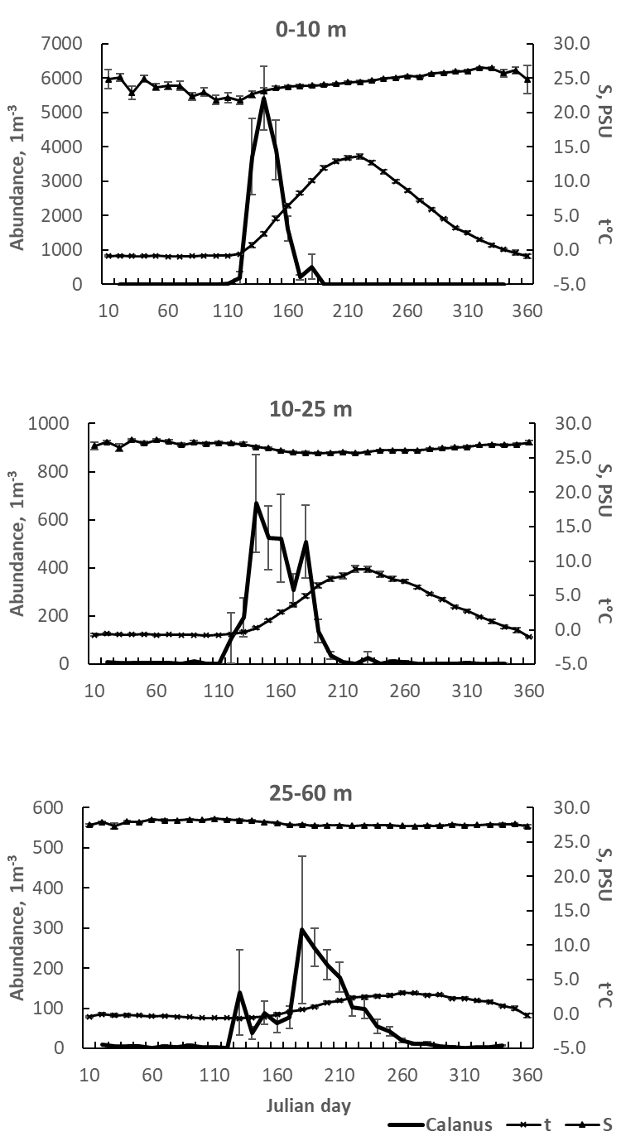
Fig. 1 Annual temperature curves recalculated for 1964-2007, station D-1. Dots – decadal mean temperature for the indicated water layer, vertical lines – standard error
Сезонная динамика численности Calanus, температуры и солености на станции Д-1 в трех слоях водной толщи. Приведены стандартные ошибки средних. (Вместо рис. 2)

EXCLUDED Spring and early summer periods, defined by temperature peculiarities, station D-1 (1964-2007). For the period definition please refer to Table 3

2) Вертикальное распределение (после рис. 3, перед суточными миграциями)
Рис. Вертикальное распределение Calanus на глубоководной (D-3) и мелководной (D-1) станциях в течение теплого периода (когда отбирали пробы на D-3).

Fig. 2 Temperature and salinity dynamics on diel stations, D-2: (a) early summer, July, 1-2, 1998; (b) late summer, Sept, 27-28, 1997. Vertical lines – daily variability

Fig. 3 Seasonal dynamics of major seston characteristics, station D-1 (2000-2008): (a) C_{org} and Chl a concentration; (b) key phytoplankton taxa concentration

) Изменение состава популяции в течение сезона (Вместо рис. 6.)
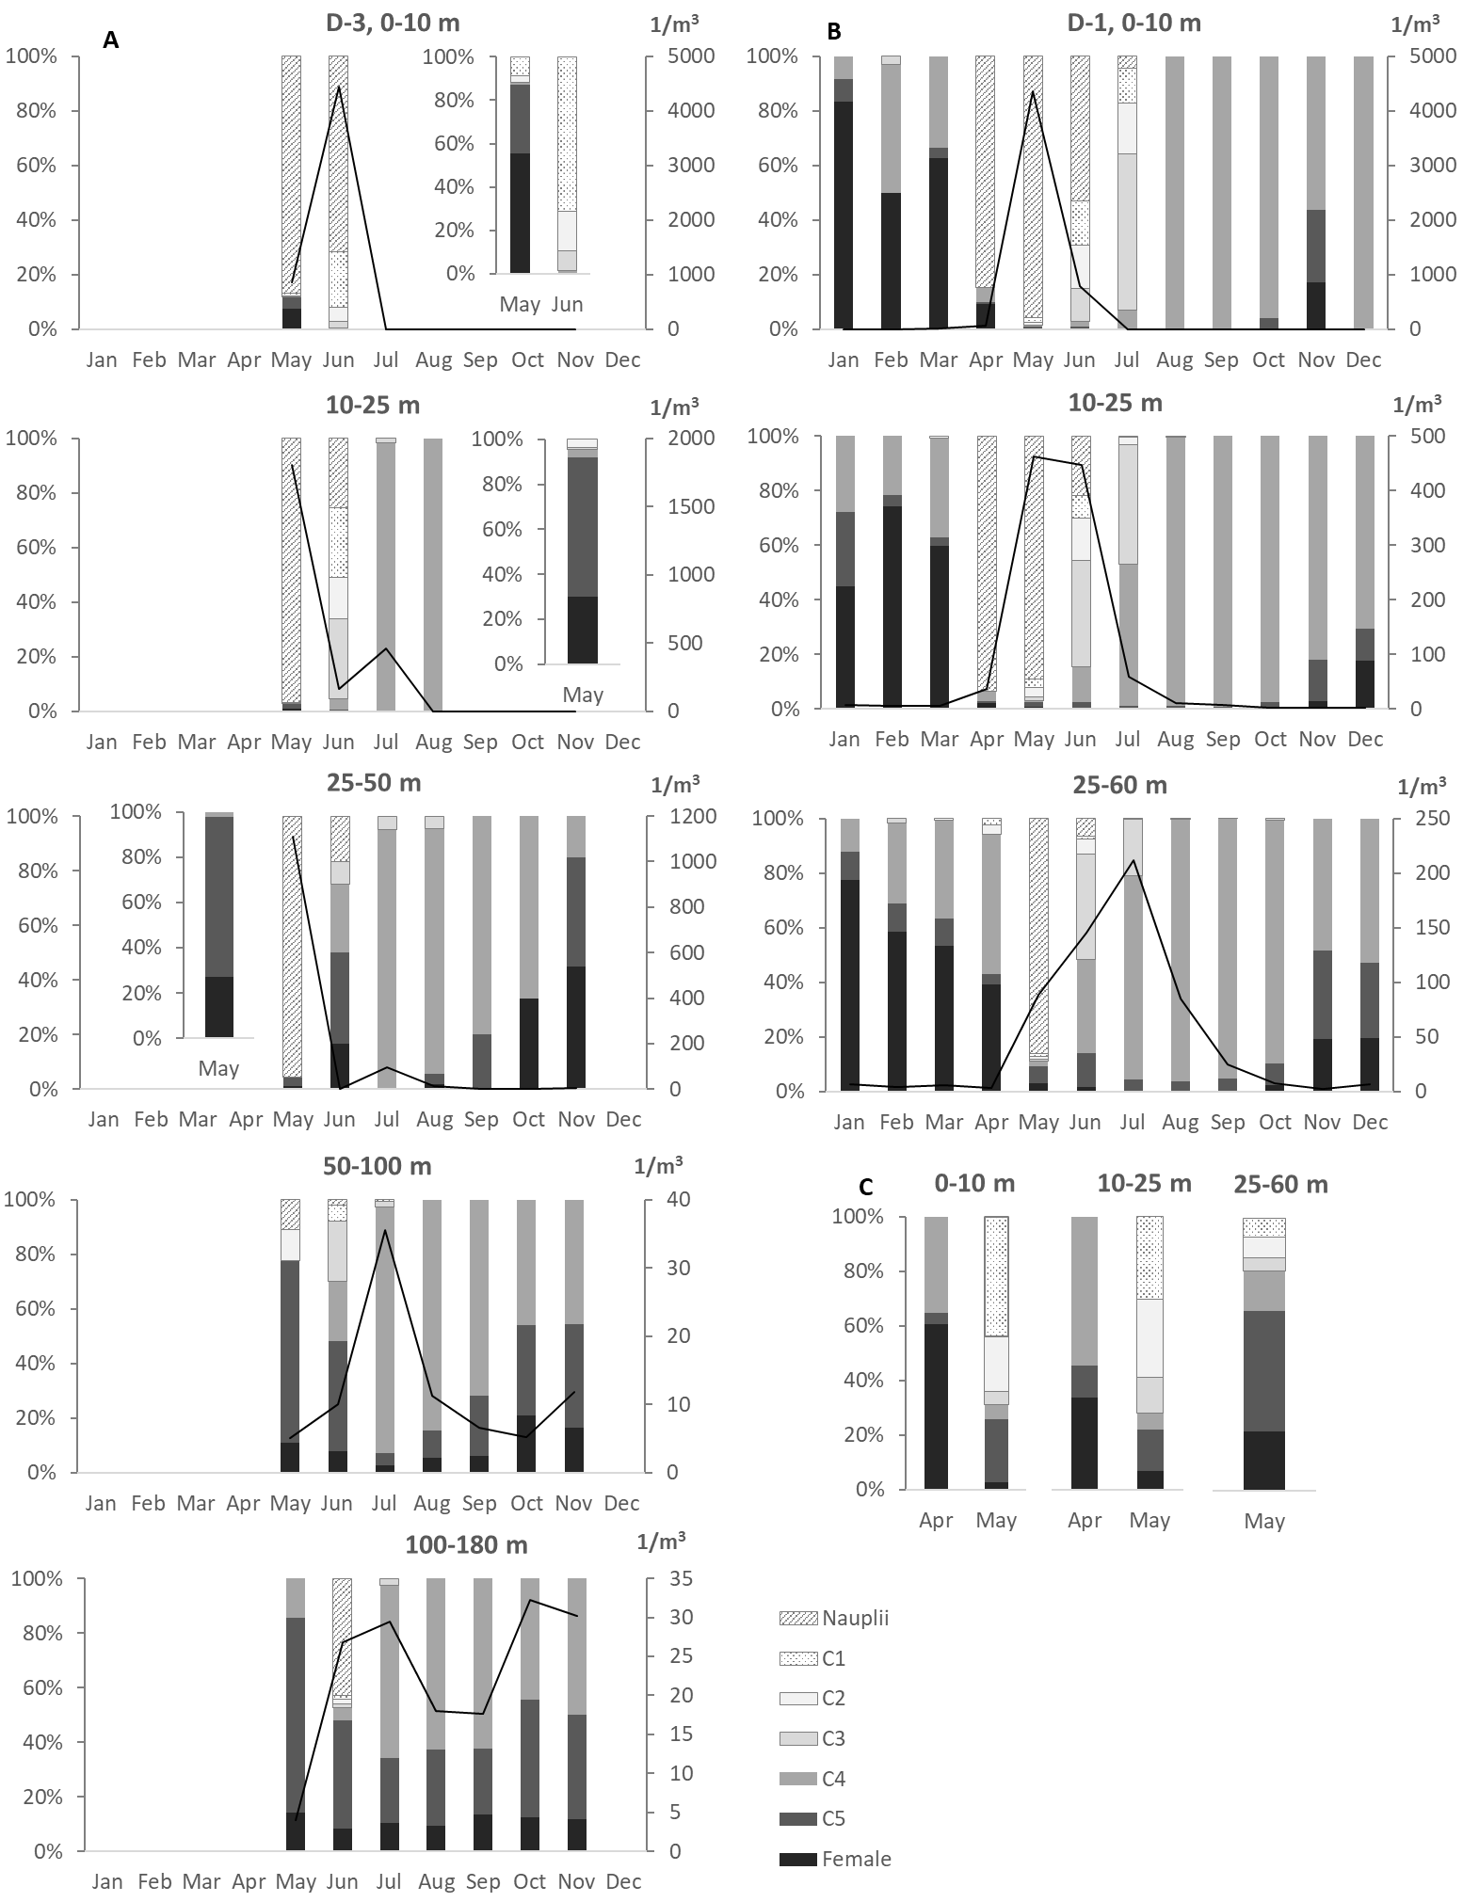

Fig. 4 Annual dynamics in vertical distribution of copepodite stages (a) and layers occupied (b) by Calanus glacialis on station D-1 (average for the period 1964-2007). Bars – decadal means; right inset – except naupliar stages. Np – nauplii; CI-CV – immature copepodites; fem – CF, females
Рис. Изменение состава популяции в течение года на глубоководной станции (А, на врезках – состав популяции без науплиев), на декадной станции (B) и на декадной станции без науплиев (C). Сплошной линией обозначена суммарная плотность популяции. Левая ось ординат – доля конкретной стадии развития в популяции; правая – плотность популяции. (Вместо рис. 6.)

Fig. 5 Daily vertical distribution of different developmental stages of Calanus glacialis on diel stations, D-2: (a) early summer, July, 1-2, 1998; (b) late summer, Sept, 27-28, 1997. Bars – daily mean; vertical lines – daily variability (differences between population depth location observed during daytime and night time)

EXCLUDED Temperature optima (recalculated range, 1964-2007) for different developmental stages of Calanus glacialis. Upper bar borders – maximal temperature, when 75% of population still stays in 0-25 m water layer. Upper lines show absolute maxima – was transferred to Arctic Species Satellite ms!

Fig. 6 Spring and early summer dynamics in L_{c}/W ratio in Calanus glacialis (2005-2008): (a) CIV copepodites; (b) CV copepodites; (c) CF, females. Bars – mean ± SE; vertical lines – max and min values. For the period definition please refer to Table 3. 0-25 and 25-65 – sampling water layers, m

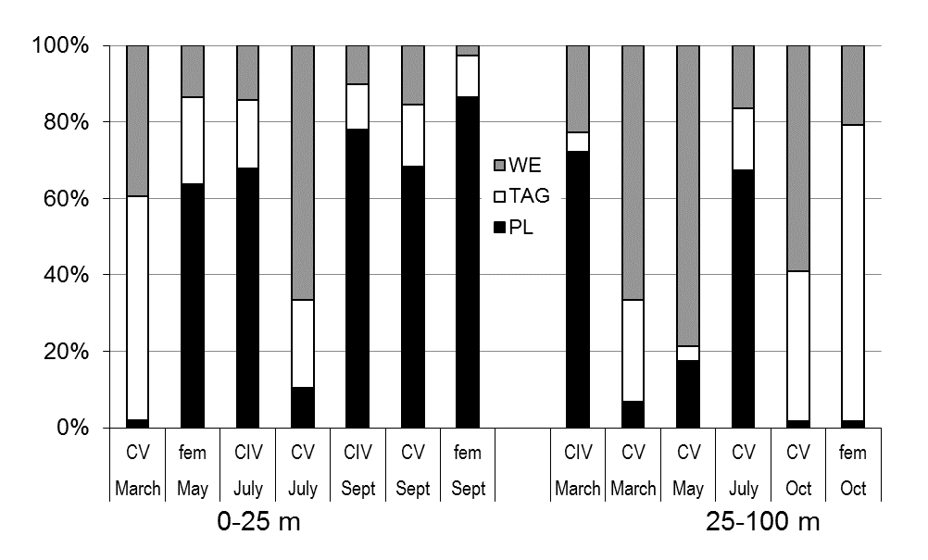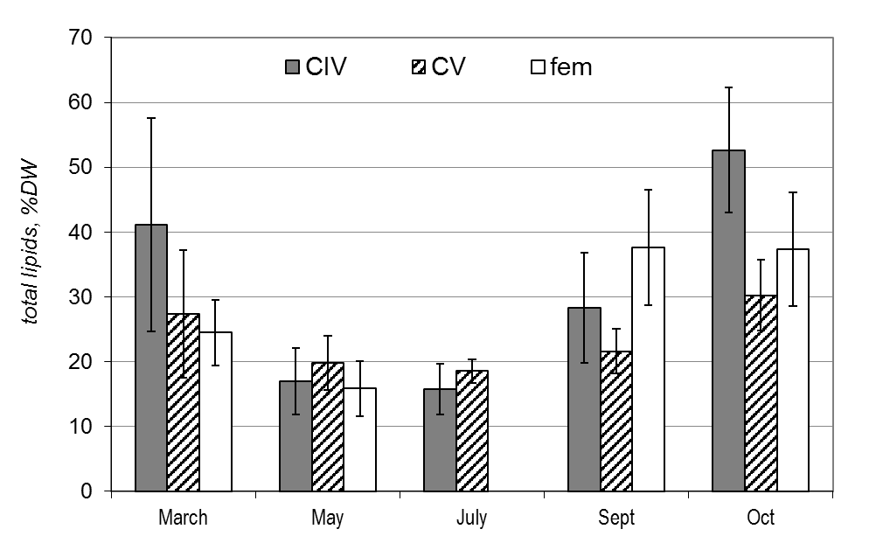
Fig. 7 Seasonal dynamics in relative lipid content in elder copepodites (CIV-CV) and females (fem) of Calanus glacialis: (a) WE – wax esters; TAG – tryacilglycerols; PL – phospholipids; (b) – total lipids. 0-25 m and 25-100 m – sampling layers

Fig. 8 Seasonal feeding characteristics of Calanus glacialis in the White Sea: (a) absolute daily ration; (b) relative daily ration; (c) percent of algal food ingested, recalculated by impact of Chl a as C_{org} in total C_{org} consumed. One asterisk* - ice algae were suggested as food; two asterisks** - animals sampled in deep layers (25-100 m) were fed by surface seston

Fig. 9 The dynamics of Calanus glacialis female gonad state in early spring (station D-3): (a) - natural population, from 50 to 68 ind.; (b) - fed females (natural phytoplankton), 50 specimens individually; (c) - starved females, 202 ind. bulk. G1-G5 – gonad stages, accordingly to Table 3

Fig. 13 Scheme of Calanus glacialis life cycle in the White Sea (compilation of original results and data by Prygunkova 1974; Kosobokova 1998, 1999). Np – naupliar stages; CI-CV – copepodite stages; dotted lines – molt periods; straight lines – overwintering without molt; DVM – diel vertical migrations (schematically), late summer period (early summer DVM are not shown); titles and numbers in the brackets indicate possible, but non-obligatory events. Note: the overwintering of all diapausing copepodite stages takes place deeper than 25 m depth

